Y4
Welcome Booklet

Cronton

Believe Enjoy Succeed Together
“I can do everything through God who gives me strength”
Philippians 4:13

Cronton CE Primary School

The KEYS Curriculum
Knowledge and skills
Empower
You to
Succeed

Keys To Success

Knowledge Skills Vocabulary

Contents

- Staff in class
- Keys Curriculum
- Learning attitudes
- Christian Vision
- Website/twitter
- Magic Keys
- Long term plans
- Timetable
- End of Year Expectations
- Homework expectations
- PE kit
- Independence
- Reading at home
- Library time
- Class Trips
- Good to be green
- Information to teachers
- Morning routine
- Dates for Diary
- Water bottles
- Snacks

Welcome to Year 4
The staff who will be working with your child this year will be:
Class Teachers – Miss Tilley
Teaching Assistant – Mrs Buckley
MFL Teacher – Mrs Kimmins
Art/D.T. Teacher – Mrs Gillies
PE Support/Coach – Mr. Doyle

Our KEYS Curriculum Intent
Our Curriculum has been designed by Cronton CE to provide a bespoke, unique and exciting curriculum that is tailor-made to suit our children, their learning and their futures. Every child is unique and important. They are at the centre of their learning; starting as part of a class, whole school, the local community and then on to their future role in modern Britain and as a future global citizen. Our KEYS curriculum develops each child and the understanding that Knowledge and skills Empower You to Succeed.

We maintain a broad and balanced approach to our curriculum, which alongside English and Mathematics will provide our children with skills, knowledge and vocabulary rich experiences that excite and engage. We will foster attitudes and qualities which will enable them to become confident, caring, respectful and responsible citizens. We offer a spiritual, moral, social and cultural experience for all through our curriculum and also through extra-curricular clubs and activities, day trips and residential experiences in KS2. We use a wide variety of resources to assist us in delivering this bespoke curriculum including specialist teachers, visits and curriculum enhancements and ensure links and relationships are meaningful to the children and their learning.

Our curriculum is planned to ensure it will build upon what children already know in a sequential way to give them powerful knowledge and skills while making relevant links to secure their understanding of the world around them. We ensure that all children receive quality first teaching for every subject with high of expectations for all. We provide a quality education that is inclusive and equips our children to be lifelong learners.

Our KEYS Curriculum:
Develops each child with, KNOWLEDGE, SKILLS and VOCABULARY. It is broad, balanced and has clear progression which is sequential in these areas

It is filled with rich purposeful first-hand experiences and uses sourced expertise. It develops values and the learning attitudes of INDEPENDENCE, PERSERVERENCE, CURIOSITY, and TEAMWORK and take RESPONSIBILITY to always be the BEST we can be.

We want our children to show RESPECT and have RESPONSIBILITY to each other and in all aspects of life. It embraces children’s knowledge and understanding of the developing world we live in, from our COMMUNITY, modern multi -cultural Britain and as a Global Citizens of the future.

Learning Attitudes

We want to instil in the children a lifelong love of learning and develop KEY Learning Attitudes with the children. We will encourage discussion and development of the KEY learning attitudes throughout the year.

Perseverance
I am resilient and determined
I have a can do attitude and never giving up
I embrace mistakes
I relish challenge
Curiosity
I ask questions and find answers
I explore and investigate new things
I have an urge to learn more
Teamwork
I work well with others
I take an active role
I contribute and share ideas
I accept others and their part to play
Independence
I am organised and set goals
I am motivated to learn
I can to do things for myself
Responsibility
I take responsibility for my own learning
I take ownership of my actions
I am confident, caring and respectful

Christian Vision
“I can do everything through God who gives me strength” Philippians 4:13

Website / Twitter
https://www.crontonce.co.uk
Please follow our class blog. We will be updating each week showing the work the children have been doing. It is lovely to see what the children have been up to and see the pictures and work they have completed.

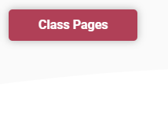

There is a lot of information on the website. Please check out on https://www.crontonce.co.uk/

The Magic Keys Passport (to replace Children’s University)
At Cronton, we strive to enable all pupils to become the BEST that they can be.
This encompasses their academic achievements as well as their personal strength of character.
At Cronton, children celebrate each other and their own qualities. We embrace new experiences, responsibilities and are proud of who we are.
We foster a love of exploring, build confidence and enhance resilience as our pupils discover their own multitude of talents and values.
Our children enjoy the journey whilst learning attributes such as cultural acceptance, respecting differences and learning how to manage their feelings.
This Magic Keys Passport aims to record and celebrate just some of the incredible achievements of our pupils whilst at Cronton C.E. Primary School and gives them some challenges to do at home as well!
Each year group has their own set of magic keys to collect across the year.
Most are keys they can achieve in school but three are for you to do at home.
At the end of the year the children will have an award ceremony where they will be awarded their Magic Key badge for the year. Each year group has a different colour badge to collect and keep.
In Year 4 we have a blue coloured key.
Everyone will receive a pennant to keep their badges on and build up over the years.
We are asking for an annual parental contribution of £2.40 to help us cover the cost.
In the Summer term there will be an award ceremony in school where we celebrate the children’s achievements.

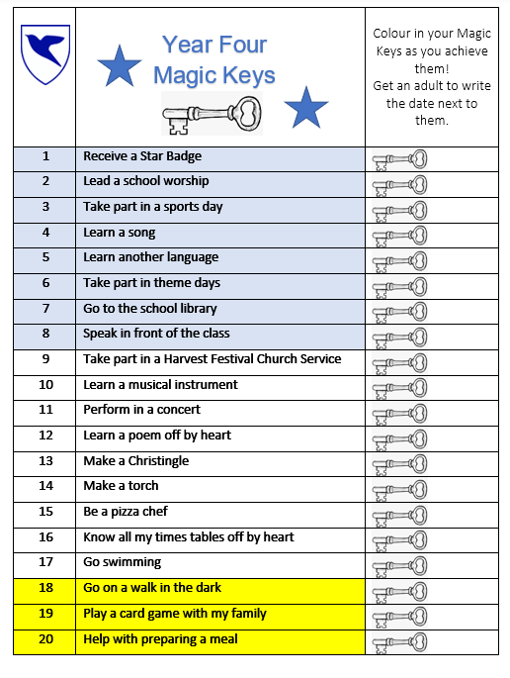

Year 4 Long Term Plans
Knowledge and Skills
Empower
You to
Succeed

Knowledge
Skills
Vocabulary

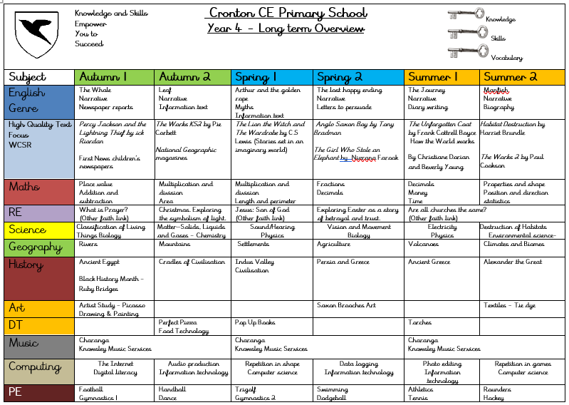
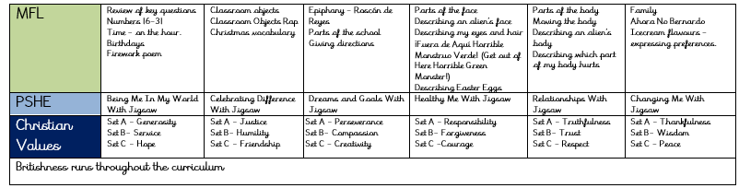

Class Timetable
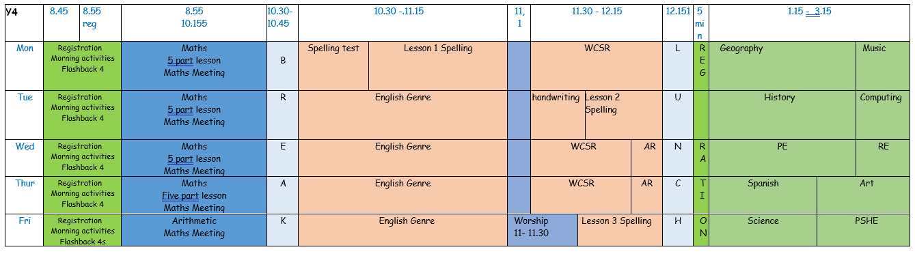

End of Year Expectations

This page provides information for parents and carers on the end of year expectations for children in our school.
The National Curriculum outlines these expectations as being the minimum requirements your child must meet in order to ensure continued progress.

All the objectives will be worked on throughout the year and will be the focus of direct teaching. Any extra support you can provide in helping your children to achieve these is greatly valued.





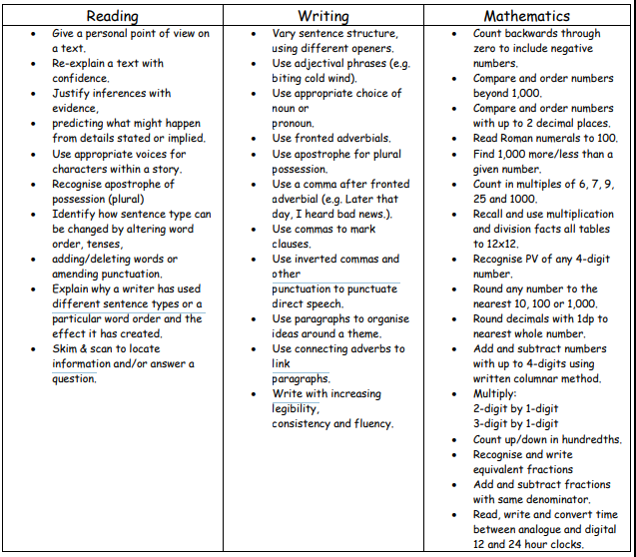
Year 4 Expectations

Homework Expectations

Reading
Reading is part of the children’s homework so they should read each school night for about 15 -20 minutes or a minimum of 5 nights. Please sign the children’s books when they read each night for 15 minutes.

Spelling
Spelling books will be sent home each Monday with new spellings. They following Monday they will be tested and given new spellings giving them a week to practise and learn the spellings or spelling rule. Please practise the spellings. A couple a night is better than all in one go. The children will also be tested on 5 secret spellings from previous list.

Homework
TT Rock stars
Spelling
Reading

P.E. Kit
This consists of a white T-shirt and royal blue shorts and for outdoor PE, a royal blue sweatshirt and plain black or navy tracksuit bottoms. The P.E. uniform is obligatory. They do not usually need to wear plimsoles / pumps for indoor P.E. as we are advised that bare foot work helps develop the feet better. Pumps should only be worn in cases of a foot infection. For outdoors, the children should pumps.

Please note that children will only be allowed to wear the outdoor kit mentioned above or their school jumper for outdoor PE. All other types of track suits, jogging suits, football kits etc will not be allowed to be worn for PE.

Earrings Policy
For safety reasons, earrings are not permitted We have listened to concerns from parents about ears closing and will be permitting the clear plastic retainers if children are unable to take earrings out until they are fully healed. For PE, these must still be covered with secure tape for safety reasons which needs to be provided by parents. Please be aware that wearing retainers are still a safety risk.

PE Day
Changes From September, we will move to one longer PE session per week. On their designated PE day, children should come to school wearing their full PE kit. Our day will be a Wednesday. If you are purchasing the new kit, please check the newsletter for more information or speak to the office.
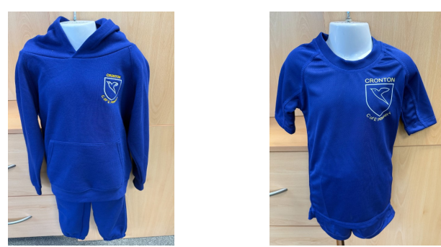

Please make sure EVERYTHING your child brings into school including uniform and PE kit has their NAME on it!

Multiplication Check - What is the Year 4 Multiplication Tables Check (MTC)?
- It’s an online test for pupils in Year 4 (ages 8–9 in England).
- The purpose is to see how well children know their times tables up to 12 × 12.
- Introduced by the UK Department for Education as a way to ensure children are fluent in multiplication facts before moving on to more advanced maths.
- Children answer 25 questions.
- Each question is a multiplication fact (e.g., 7 × 8).
- Pupils have 6 seconds to answer each question, with a 3-second pause before the next one.
- It usually takes no more than 5 minutes to complete.

Websites to help
Multiplication Tables Check - Mathsframe
Multiplication Tables Check - 2025 - Timestables.co.uk
You Tube – Different Times table songs
TT Rock Stars

Reading at Home
At Cronton we would like to instil a love of reading. Reading is a high priority to us in every year. We hope that you continue to help in this very important area. To help this try and:
- Have books changed regularly so a variety of genres are read.
- Encourage daily reading aloud / story reading and discussion of books.
- Quality time rather than quantity is vital.
- Please assist the staff by encouraging your child’s reading at home by sharing books, listening to and reading with your child.
- Use dictionaries to clarify meanings of unknown words.
- Children should bring their book in each day and place in tray first thing in the morning.
- Ask questions about the text to infer and discuss point of view.
Please ensure that you sign the reading record book to show that your child has read to complete the reading challenge.

Reading Ninja Challenge
In a drive to reward the children who read more at home, Cronton C of E Primary School are continuing to run the Reading Ninja Challenge. The children will be rewarded with ‘Reading Belts’ in the form of a certificate. To gain a belt they will need to read 25 times. For a 'read' to count towards a band your child needs to share a book with an adult for at least 10-15 minutes. This could be their school reading book, library book, book from home or a comic.
An adult must sign their reading record book and only one read per day counts (so there is a maximum of seven reads per week). Older, confident readers may read to themselves but must still have their reading record signed by an adult. We recommend a period of a minimum of 15 minutes for a signature in their reading record. Class teachers will ask for your child's reading record every week to total and record the number of reads for each child. As they gain more signatures, they will progress through the coloured belts. We hope that this will be an exciting way of encouraging the children to read at home every day.

The belts:  300
275
250
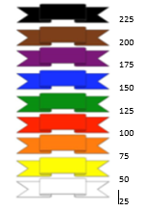
Library Time
Our class has been given an allocated slot to visit the school library. The children will be able to choose a book from the library to take home. This may be one that they can enjoy themselves or choose one to be read to them. They can keep the book until they have finished. They will only be allowed to change the book once they have returned the current book.

Class Trips
Liverpool Museum (November time - TBC)
Chester Zoo (May time – TBC)

Good to be Green
Good to be Green
We have four rules in school.
Be Ready! Be Respectful! Be Safe! Be Kind!
When the children follow these rules, they stay on a green card.
When they do not follow these rules the following system of sanctions will apply.
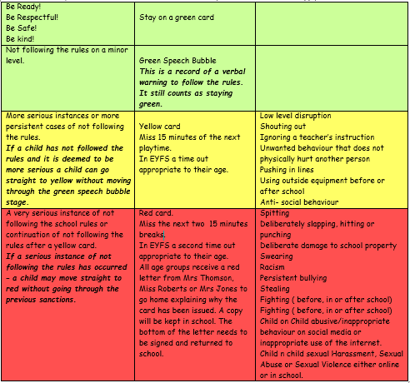

These are examples only and not a definitive list of the behaviours that might incur a sanction.
Extremely serious cases of not following the rules may result in a temporary exclusion from school.

Messages for the teacher
If you would like to speak to me, you can contact the school through the crontonce@ldst.org email and this will be forwarded to me. Please allow up to 3 days to respond. If you need to speak to me urgently then please call the office and leave a message and I will speak to you at the earliest opportunity. You can pass a message through Miss Roberts on the door in the morning.

Morning and Home Routine
Children will continue to enter the school through the main door in the morning and out through the classroom door in the afternoon.

Dates for Your Diary
European Day of Language: Monday 26th September. We are learning about Greece.
Other events will be coming up and we will let you know as soon as these are confirmed.

Water bottles
Please provide a water bottle for your child each day to help with the smooth running of the classroom. This is so they don't have to leave the classroom for a drink. This should be filled with water only - NO JUICE OR FLAVOURED WATER.

Snacks
Your child is allowed a healthy snack during break times. If you wish for your child to have a piece of toast on Tuesdays for their snack, please pay via ParentPay. The cost will be £7.50 and will cover a piece of toast each week up to when we finish school in July 2026.
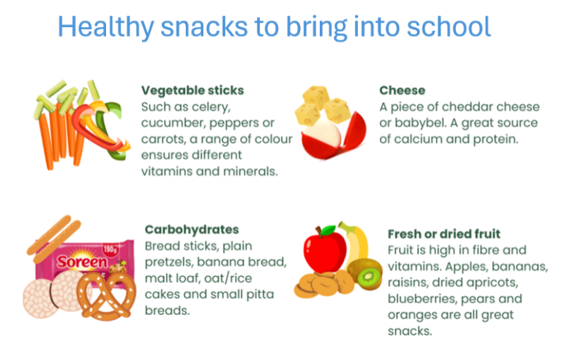

At lunch times, we also have the Swap Station.
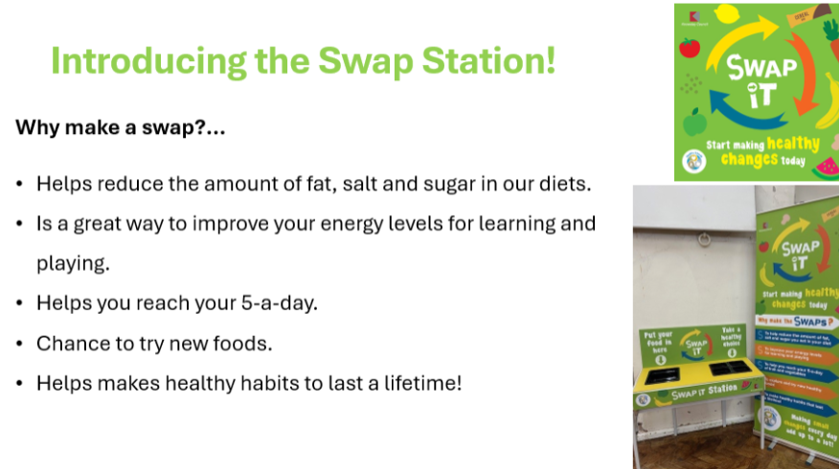

Music tuition
This year, children will get violin lessons. They can only bring the violin in school each Monday and rent the violin for a year. At the end of the year, they will get the opportunity to perform in the summer concert.

