Y3
Welcome Booklet

Cronton

Believe Enjoy Succeed Together
“I can do everything through God who gives me strength”
Philippians 4:13

Cronton CE Primary School

The KEYS Curriculum
Knowledge and skills
Empower
You to
Succeed

Keys to Success

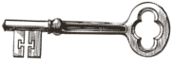Knowledge Skills Vocabulary

Contents

- Staff in class
- Keys Curriculum
- Learning attitudes
- Christian Vision
- Website/twitter
- Children’s University
- Timetable
- Long term plans
- End of Year Expectations
- Homework expectations
- PE kit
- Independence
- Reading at home
- Library time
- Class Trips
- Good to be green
- Information to teachers
- Morning routine
- Dates for Diary
- Water bottles
- Snacks
- Music Tuition
- Common Exception Words for Year 2 and 3/4
Welcome to Year 3
The staff who will be working with your child this year will be:
Class Teachers – Miss Gill
Teaching Assistant – Mrs Buckley
MFL Teacher – Mrs Kimmins
Art/D.T. Teacher – Mrs Gillies

KEYS Curriculum

Our KEYS Curriculum Intent
Our Curriculum has been designed by Cronton CE to provide a bespoke, unique and exciting curriculum that is tailor-made to suit our children, their learning and their futures. Every child is unique and important. They are at the centre of their learning; starting as part of a class, whole school, the local community and then on to their future role in modern Britain and as a future global citizen. Our KEYS curriculum develops each child and the understanding that Knowledge and skills Empower You to Succeed.

We maintain a broad and balanced approach to our curriculum, which alongside English and Mathematics will provide our children with skills, knowledge and vocabulary rich experiences that excite and engage. We will foster attitudes and qualities which will enable them to become confident, caring, respectful and responsible citizens. We offer a spiritual, moral, social and cultural experience for all through our curriculum and also through extra-curricular clubs and activities, day trips and residential experiences in KS2. We use a wide variety of resources to assist us in delivering this bespoke curriculum including specialist teachers, visits and curriculum enhancements and ensure links and relationships are meaningful to the children and their learning.

Our curriculum is planned to ensure it will build upon what children already know in a sequential way to give them powerful knowledge and skills while making relevant links to secure their understanding of the world around them. We ensure that all children receive quality first teaching for every subject with high of expectations for all. We provide a quality education that is inclusive and equips our children to be lifelong learners.

Our KEYS Curriculum:
Develops each child with, KNOWLEDGE, SKILLS and VOCABULARY. It is broad, balanced and has clear progression which is sequential in these areas

It is filled with rich purposeful first-hand experiences and uses sourced expertise. It develops values and the learning attitudes of INDEPENDENCE, PERSERVERENCE, CURIOSITY, and TEAMWORK and take RESPONSIBILITY to always be the BEST we can be.

We want our children to show RESPECT and have RESPONSIBILITY to each other and in all aspects of life. It embraces children’s knowledge and understanding of the developing world we live in, from our COMMUNITY, modern multi -cultural Britain and as a Global Citizens of the future.

Learning Attitudes
We want to instil in the children a lifelong love of learning and develop KEY Learning Attitudes with the children. We will encourage discussion and development of the KEY learning attitudes throughout the year.

Perseverance
I am resilient and determined
I have a can do attitude and never giving up
I embrace mistakes
I relish challenge
Curiosity
I ask questions and find answers
I explore and investigate new things
I have an urge to learn more
Teamwork
I work well with others
I take an active role
I contribute and share ideas
I accept others and their part to play
Independence
I am organised and set goals
I am motivated to learn
I can to do things for myself
Responsibility
I take responsibility for my own learning
I take ownership of my actions
I am confident, caring and respectful

Christian Vision
“I can do everything through God who gives me strength” Philippians 4:13

Website / Twitter
There is a lot of information on the website. Please check out on https://www.crontonce.co.uk
Please follow our class blog. We will be updating each week showing the work the children have been doing. Find it under class pages.
Twitter
Please follow us on Twitter at @Crontonceschool
We will be posting weekly posts about the children.

Children’s University has been replaced with a ‘Magic Key Passport’
Cronton C.E. Primary

Magic Key Passport

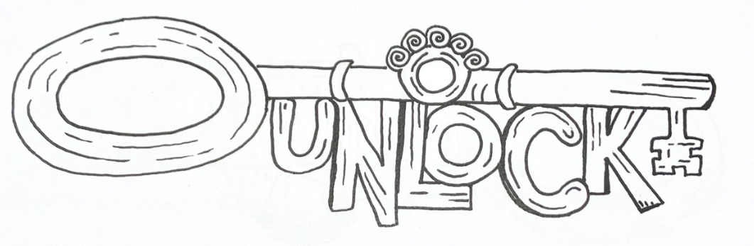

Believe Enjoy Succeed Together
“I can do everything through God who gives me strength”
Philippians 4:13
At Cronton, we strive to enable all pupils to become the BEST that they can be.
This encompasses their academic achievements as well as their personal strength of character.
At Cronton, children celebrate each other and their own qualities. We embrace new experiences, responsibilities and are proud of who we are.
We foster a love of exploring, build confidence and enhance resilience as our pupils discover their own multitude of talents and values.
Our children enjoy the journey whilst learning attributes such as cultural acceptance, respecting differences and learning how to manage their feelings.
This Magic Keys Passport aims to record and celebrate just some of the incredible achievements of our pupils whilst at Cronton C.E. Primary School and gives them some challenges to do at home as well!

 | Year Three  Magic Keys  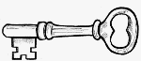 | Colour in your Magic Keys as you achieve them!  Get an adult to write the date next to them.
1 | Receive a Star Badge | 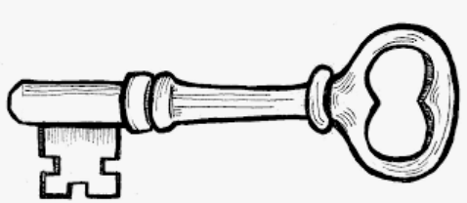
2 | Lead a school worship
3 | Take part in a sports day
4 | Learn a song
5 | Learn another language
6 | Take part in theme days
7 | Go to the school library
8 | Speak in front of the class
9 | Lead a Harvest Festival Church Service
10 | Make a puppet
11 | Build a bridge
12 | Create a stop frame animation
13 | Print some wrapping paper
14 | Be a Roman Legionnaire
15 | Have a taster at learning a musical instrument
16 | Learn a poem off by heart
17 | Be a potter
18 | Visit a new place
19 | Play a board game with my family
20 | Help with the dishes after a meal

Class Timetable
Current Timetable
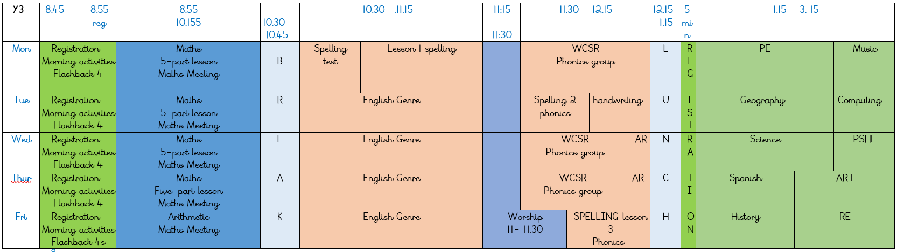

Long Term Plan

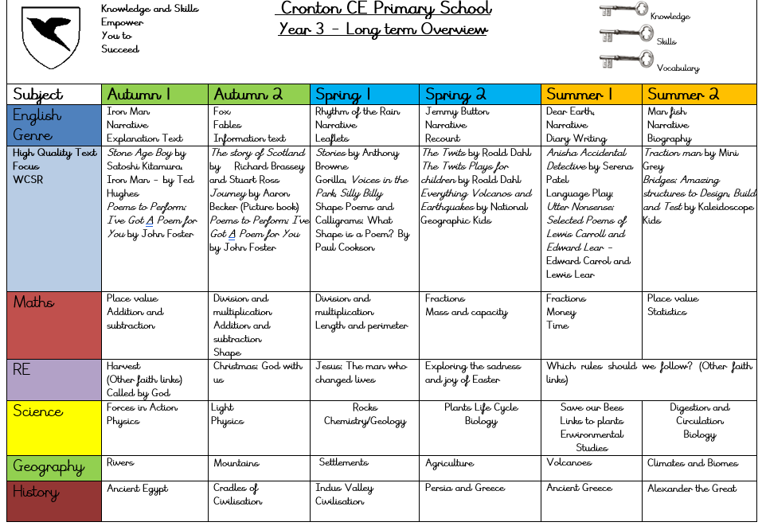

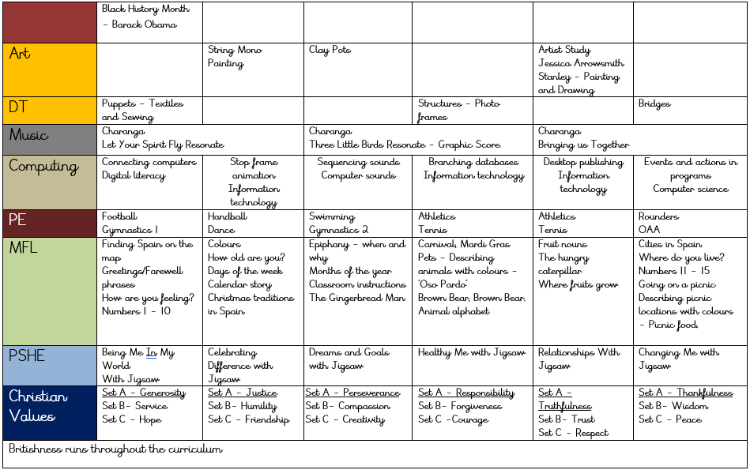

End of Year Expectations
This page provides information for parents and carers on the end of year expectations for children in our school. The National Curriculum outlines these expectations as being the minimum requirements your child must meet in order to ensure continued progress. All the objectives will be worked on throughout the year and will be the focus of direct teaching. Any extra support you can provide in helping your children to achieve these is greatly valued.
If you have any queries regarding the content of this page or want support in knowing how best to help your child, please talk to your child’s teacher.




Reading | Writing | Mathematics
- Read common exception words, noting the unusual correspondences between spelling and sound, and where these occur in the word  - Use a dictionary to check the meaning of words that I am unsure of  - identify themes e.g. the triumph of good over evil, and conventions e.g .the greeting in letters, in a wide range of books  - draw inferences such as inferring characters' feelings, thoughts and motives from their actions, and can justify inferences with evidence  - Predict what might happen from details stated and implied  - Retrieve and record information from non-fiction e.g. using contents pages and indexes to locate information | - Organise paragraphs around a theme  - In narratives, create settings, characters and plot  - In non-narrative material, use simple organisational devices [for example, headings and sub-headings]  - proofread my work for spelling and punctuation errors  - write sentences with more than one clause, expressing time, place and cause using a wider range of conjunctions, e.g when, before, after, while, so, adverbs e.g. then, next, soon, therefore, or prepositions  - Use the present perfect form of verbs in contrast to the past tense, e.g. He has gone out to play contrasted with He went out to play.  - Use the form a or an according to whether the next word begins with a vowel or consonant  - Use inverted commas to punctuate direct speech | - Count from 0 in multiples of 2, 5, 10 50 and 100;  - Know the place value of each digit in a 3-digit number (100s, 10s, 1s)  - Find 10 or 100 more or less than a given number  - Solve number problems.  - Add and subtract mentally a three-digit number and 1s , 10s and 100s  - recall and use multiplication and division facts for the 2, 3, 4, 5, 8 and 10 times tables  - calculate mathematical statements including two-digit numbers times one-digit numbers, using mental and progressing to formal written methods  - count up and down in tenths; recognise that tenths arise from dividing an object into 10 equal parts  - Recognise, find and write fractions of objects: and numbers e.g. 1/2 1/4 1/3  - Recognise and show, equivalent fractions  - Measure, compare, add and subtract: lengths (m/cm/mm); mass (kg/g); volume/capacity (l/ml)  - Add and subtract amounts of money to give change, using both pounds and pence  - Tell and write the time from an analogue clock, 12-hour and 24-hour clocks  - Identify right angles, recognise that 2 right angles make a half-turn, 3 make three-quarters of a turn and 4 a complete turn  - Identify whether angles are greater than or less than a right angle  - Interpret and present data using bar charts, pictograms and tables

Homework Expectations
Reading
Reading is part of the children’s homework so they should read each school night for about 10 -15 minutes 4-5 a week. Please sign the children’s journal when they read each night for 15 minutes. Some children are on AR books (accelerated reading), others are reading RWI books. Children are split into different groups for accelerated reading/phonics.
Times Tables
Children should be practicing these daily. Please ask them 3 or 4 quick fire tables question each day. They should be aiming for instant recall. Children in Year 3 need to know the 2, 3, 4, 5, 8 and 10 times tables. Children will take part in the national times table check next year in Year 4. They will need to know ALL multiplication tables up to 12 x 12 for this. Therefore, any help this year towards this will benefit them. We will have regular times tables tests in school.
Spelling
Spelling books will be sent home each Monday with new spellings. The following Monday they will be tested and given new spellings giving them a week to practise and learn the spellings or spelling rule. Please practise the spellings. A couple a night is better than all in one go. The children may also be tested on some secret spellings from a previous list or high-frequency words.

P.E Kit
This consists of a white T-shirt and royal blue shorts and for outdoor PE, a royal blue sweatshirt and plain black or navy tracksuit bottoms. The P.E. uniform is obligatory. Children are now required to wear black pumps.
If you do not wish to purchase this outdoor PE kit, the children should wear their school cardigan / jumper with their PE shorts or black or navy jogging bottoms for outdoor PE lessons when the weather is cold. Please note that children will only be allowed to wear the outdoor kit mentioned above or their school jumper for outdoor PE. All other types of track suits, jogging suits, football kits etc will not be allowed to be worn for PE.

We are going swimming in the spring term.

Please make sure EVERYTHING your child brings into school including uniform and PE kit has their NAME on it

Independence
As children move into Year 3, more independence is expected to prepare the children for KS2. Your support is greatly appreciated with this. The children need to take responsibility for bringing in letters and looking after their belongings etc.

Reading at Home (See also Homework section)
At Cronton, we would like to instil a love of reading. Reading is a high priority to us in every year. We hope that you continue to help in this very important area. To help this try and:
- Have books changed regularly so a variety of genres are read.
- Encourage daily reading aloud / story reading and discussion of books.
- Quality time rather than quantity is vital.
- Please assist the staff by encouraging your child’s reading at home by sharing books, listening to and reading with your child.
- Use dictionaries to clarify meanings of unknown words.
- Children should bring their book in each day and place in their tray first thing in the morning.
- Ask questions about the text to infer and discuss point of view.
Please ensure that you sign the reading record book to show that your child has read to complete the reading challenge.

Reading Ninja Challenge
In a drive to reward the children who read more at home, Cronton C of E Primary School are continuing to run the Reading Ninja Challenge. The children will be rewarded with ‘Reading Belts’ in the form of a certificate. To gain a belt they will need to read 25 times. For a 'read' to count towards a band your child needs to share a book with an adult for at least 10-15 minutes. This could be their school reading book, library book, book from home or a comic.
An adult must sign their reading record book and only one read per day counts (so there is a maximum of seven reads per week). Older, confident readers may read to themselves but must still have their reading record signed by an adult. We recommend a period of a minimum of 15 minutes for a signature in their reading record. Class teachers will ask for your child's reading record every week to total and record the number of reads for each child. As they gain more signatures, they will progress through the coloured belts. We hope that this will be an exciting way of encouraging the children to read at home every day.
The belts:  300
275
250
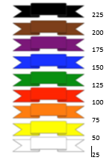
Library Time
Our class has been given an allocated slot to visit the school library on Wednesday mornings. The children will be able to choose a book from the library to take home. This may be one that they can enjoy themselves or choose one to be read to them. They can keep the book until they have finished. They will only be allowed to change the book once they have returned the current book.

Class Trips
We are hoping to go on a trip to Tatton Park for a Stone Age workshop and a day in Chester for a ‘Roman’ day. More information will follow.

Good to be Green
We have four rules in school.
Be Ready! Be Respectful! Be Safe! Be Kind!
When the children follow these rules, they stay on a green card.
When they do not follow these rules the following system of sanctions will apply.
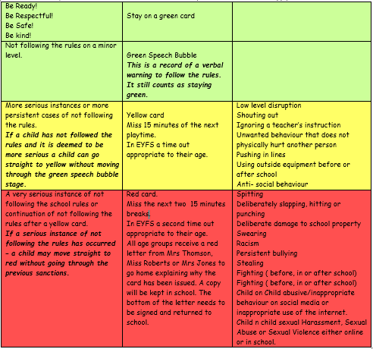

These are examples only and not a definitive list of the behaviours that might incur a sanction.
Extremely serious cases of not following the rules may result in a temporary exclusion from school.

Messages for the teacher
If you would like to speak to me, you can contact the school through the crontonce@ldst.org email and this will be forwarded to me. I will contact you either at lunchtime or after school. If you need to speak to me urgently then please call the office and leave a message and I will speak to you at the earliest opportunity. You can pass a message through Miss Nesbo on the door in the morning,
Morning and Home Routine
Children will continue to enter the school through the main door in the morning at 8.45am and out through the class door at the end of school at 3.20pm.

Dates for Your Diary
European Day of Language: Thursday 26th September We are learning about Switzerland
Harvest Festival: Friday 27th September
Parents evening Monday 21st October and Tuesday 22nd October 3:30-6pm
Stone Age Trip at Tatton Park: Wednesday 23rd October
Other events will be coming up and we will let you know as soon as these are confirmed. Please keep up to date with the newsletter.

Water bottles
Please provide a water bottle for your child each day to help with the smooth running of the classroom. This is so they don't have to leave the classroom for a drink. This should be filled with water only - NO JUICE OR FLAVOURED WATER. This should have a ‘sports’ bottle type lid and not a screw top wherever possible to avoid spillages.

Snacks and lunches
Your child is allowed a healthy snack during break time Monday to Thursday. They are allowed a small “treat” snack on a Friday first break. If you wish for your child to have a piece of toast on Tuesdays for their snack, please pay via ParentPay. The cost will be £7.50 and will cover a piece of toast each week up to when we finish school in July 2024.
Please note:
1. Children no longer get milk/fruit in the afternoons.
2. School lunches are no longer free in KS2.

Music tuition
Children will be having keyboard taster sessions in small groups. There is no charge for this. There may be opportunity to continue with paid keyboard lessons after this.

Year 2 Common Exception Words
Your children will receive a copy with the words highlighted that they scored incorrect in September. Please try to learn these before we retest children at the end of the autumn term. We will be working on them in class too.

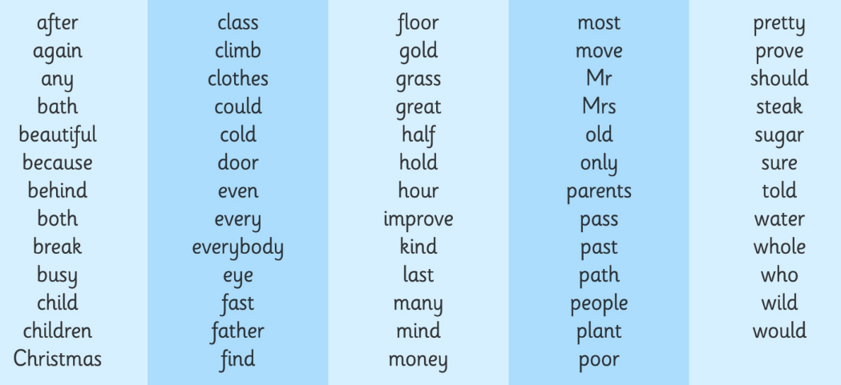

Year 3 and 4 Common Exception Words
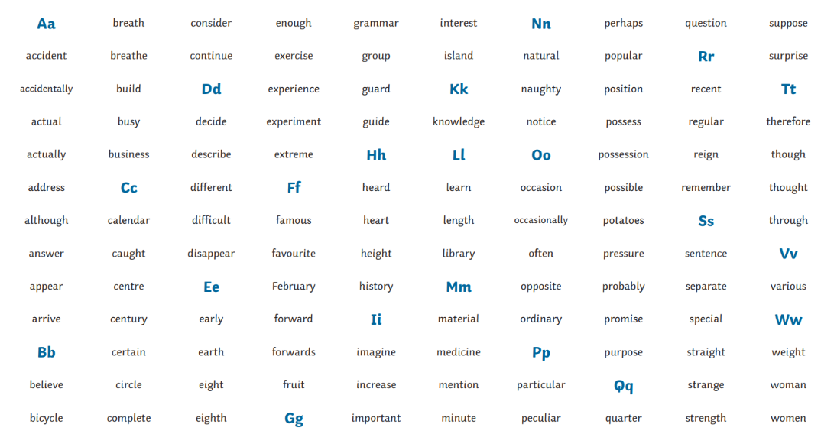
Your child will be expected to know all of these words by the end of Year 4.

