Spirituality Policy

OUR TRUST PRAYER
Heavenly Father,
Let peace, friendship and love grow in our schools.
Send the Holy Spirit to give
excellence to our learning,
love to our actions and
joy to our worship.
Guide us to help others,
so that we may all
Learn, Love and Achieve, Together with Jesus.

Contents
Legal Framework: Links to OFSTED and SIAMS expectations 3
School Statement on Spirituality 3
Aims 4
Organisation 4
Spirituality in Collective Worship 5
Spirituality in Religious Education 5
Spirituality within the Curriculum 5
Spirituality within the Ethos of the Daily Life of the School 8
Recording, Monitoring and Evaluation 8
Roles and Responsibilities 8
Staff Development and Training 9
Additional Support Material 10

Legal Framework: Links to OFSTED and SIAMS expectations
The OFSTED School Inspection Handbook, November 2019 No. 190017, page 59 & 60, states:
Inspectors will evaluate the effectiveness of the school’s provision for pupils’ spiritual, moral, social and cultural education. This is a broad concept that can be seen across the school’s activities but draws together many of the areas covered by the personal development judgement.
Provision for the spiritual development of pupils includes developing their:
- ability to be reflective about their own beliefs (religious or otherwise) and perspective on life
- knowledge of, and respect for, different people’s faiths, feelings and values
- sense of enjoyment and fascination in learning about themselves, others and the world around them
- use of imagination and creativity in their learning
- willingness to reflect on their experiences.
The SIAMS Evaluation Schedule for Schools and Inspectors, April 2018, includes the question:
- How well does the school support all pupils in their spiritual development, enabling all pupils to flourish? (Strand 2)

LDST Statement on Spirituality

Spirituality is a deep connection to ourselves, others and the wider world, brought about by a sense of belonging and appreciation of the beauty and wonder of God’s creation. It is a broader sense of personal and moral development; allowing an individual to explore the person they want to become.
Spirituality becomes the recognition that there is something much greater than oneself, which invites a response; bringing insight, reflection and meaning. It is our ability to be present and ‘in the moment’ allowing us to delight in the awe and wonder of all that we encounter and give us a sense of meaning and purpose in life.

To ensure the language we use to define spirituality is child-friendly, when talking to children about it, Cronton CE will refer to the concepts of:
Window, Mirrors and Doors
The language of windows, mirrors and doors is used as a structure to allow children and adults to think spiritually:
Windows (learning):
- Opportunities for children to be aware of the world in new ways, looking out into the world.
- To wonder about life's 'WOWS’. Things that are amazing.
- To think about life's 'OWS' that take us by surprise!
- Learning about life in all its fullness.
Mirrors (reflecting):
- Looking inside yourself.
- Opportunities to reflect on their experiences.
- Consider life's big questions and reach for some possible answers.
- Learning from life by exploring our own insights and those of others.
Doors (responding):
- Opportunities for children to respond.
- Moving onto a new path or mindset.
- To do something creative to develop and apply our ideas.
- Learning to live out our beliefs and values.

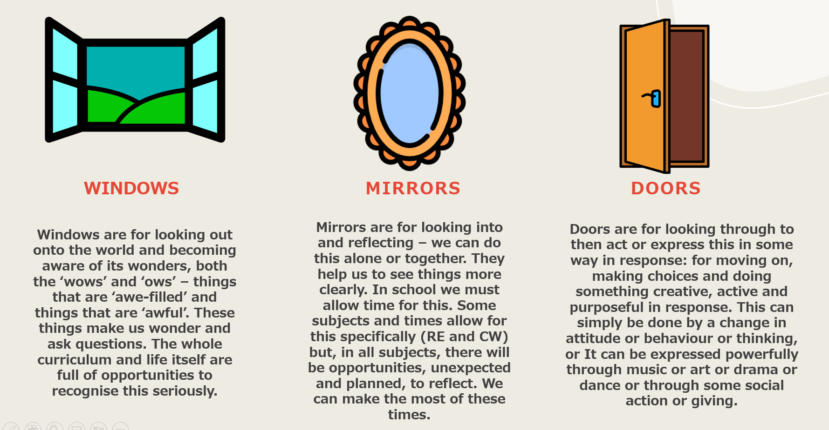

School’s Name

Cronton CE School
School’s Christian Vision:

I can do everything through God who gives me strength. Philippians 4:13

Our school vision, “I can do everything through God who gives me strength” (Philippians 4:13), is the foundation of all we do. Written by Paul during a time of great hardship, this verse speaks of triumph through faith—finding peace and contentment even in adversity. At Cronton, children, staff, and families journey together through life’s highs and lows, united by our motto: Believe, Enjoy and Succeed Together. Through our relationship with God, we learn to face challenges with courage and grace, drawing strength from Him to live with purpose and peace. This vision empowers us to live out our Christian faith boldly, embrace our values, and shine in our communities. With God’s help, we strive to be inclusive and provide every child with the best possible education.
We are committed to ensuring we develop the whole child, linked to Church of England’s vision for education: John 10:10 - “life in all its fullness”.
Our trust vision ‘Learn, Love and Achieve together with Jesus’ supports what we do as a school as we seek to journey through life together as a family with Jesus as our cornerstone. We want to be a school defined by love and a school where all members of the community feel loved, feel like they learn and ultimately feel like they achieve. We can do each of these things through God who gives us the strength to do so.

Organisation

The spiritual growth of pupils is not only dependent on learning in RE, opportunities for enhancing the spiritual well-being of learners are developed in every aspect of our school life.
We support the whole school community to share this responsibility and to develop the shared language of spirituality. Opportunities are available for all to develop spiritually in our supportive and nurturing school inspired by our vision and lived out through our Christian values.
Our school’s physical environment supports opportunities for spiritual growth and reflection for all of our pupils. We have spaces around school for prayer indoor and outdoor.
We have identified specific areas which contribute to the spiritual growth of pupils: collective worship, the whole curriculum, including RE and the general ethos of the school within daily life.
Spirituality in Collective Worship
Collective Worship is the beating heart of Cronton CE. It provides the opportunity for our school community to share experiences, ideas and understanding. It is the context in which the language of spirituality, which we use as a school, is regularly and explicitly shared.
Collective Worship provides the opportunity for pupils to become aware of the importance of reflection and how our positive and negative experiences can be formative. It also provides a real sense of being present which are often linked to invitations to pray.
Through daily Collective Worship, pupils are offered a space and a place for hearing the Christian story. They are offered an understanding of worship by being invited to participate in, or observe, Christian spiritual practices such as: prayer, reading and reflection on the Bible and liturgy and are introduced to different musical traditions.
Opportunities to learn about self and others and delight in the beauty and joy of God’s world, as well as time to reflect and empathise with the struggles and puzzles, moments of disappointment or pain. Pupils are encouraged to consider their responsibilities to others, to grow in love and service and given time to take action. Time is given for celebration, both for the accomplishments of school members and to mark seasonal Christian festivals and celebrations in the calendars of other faiths. In this way pupils are offered time to be able to contemplate and develop spiritually, linking this to the language of Windows, Mirrors and Doors where appropriate.
Collective Worship at Cronton CE is invitational, inspirational and inclusive.

Spirituality in Religious Education
The Church of England’s Statement of Entitlement outlines the aims and expectations for Religious Education in Church of England Schools and guides this school’s approach to RE and spirituality.
Learning activities in RE provide for the needs of all pupils, offering a safe space to explore their own religious, spiritual and/or philosophical ways of seeing, living and thinking, believing and belonging. They provide opportunities to engage in meaningful and informed dialogue with those of all religions and worldviews, linking these to pupils’ ideas of spirituality and the language of Windows, Mirrors and Doors where appropriate.
We use Windows, Mirrors and Doors as an assessment tool at the end of RE units, as well as other units across the wider curriculum as this allows children to take their learning from being not just head knowledge, but heart knowledge.

Spirituality within the Curriculum
Drawing on the language of Windows, Mirrors and Doors, conversations around spirituality will be included in classroom teaching when appropriate from EYFS to Year 6.
Maths
Points to consider:
- The wonder of number patterns
- What cannot be measured? For example, love
- What cannot be accurately counted? For example, the difference an act of kindness makes.
Reading
Points to consider:
- How do you frame questions around a text? For example
  - What inspired you in this text?
  - How did a character cope with a challenge in life?
  - How did the actions of a character surprise you? What can you learn about others and yourself? What are the struggles and puzzles this makes you think about?
  - What do you think makes these words so powerful/beautiful/painful?
Writing
Points to consider:
- If pupils are invited to write about things that have profound meaning to them, how is this writing valued? How can it be recognised as having value, rather than simply be reduced to an evaluation of SPAG?
DT
Points to consider:
- What motivates designers and their decisions? For example, is it a desire to make money or a desire to help and make improvements to daily life for everyone?
Music
Points to consider:
- What style of music ‘invites you to explore the mystery that dances within your soul’?
- What styles of music have the opposite effect?
- How does music encourage creativity, delight, and curiosity?
MFL
Points to consider:
- What motivates language learning? For example, buying an ice cream on holiday or welcoming and comforting a stranger in our country?
- What does it feel like to genuinely communicate with someone in a new language?
Geography
Points to consider:
- The delight of physical geography
- The struggles and puzzles of discovering different physical regions do not provide the same opportunities.
- What options/opportunities are there to respond and take responsibility in a challenging world?
History
Points to consider:
- What can we learn about others and ourselves?
- Which stories tell historical struggles and puzzles?
- What lessons for future decisions and choices do they provide?
PE
Points to consider:
- How do you celebrate a new skill? How does it feel to be proud of your whole self?
- What does it feel like to be completely focused on a task or challenge?
- How do you recognise the delight in movement, connectedness, and creativity?
- Encourage the awareness of one’s own strength and limitations.
- Recognise/celebrate equality, freedom, respect and trust.
Science
Points to consider:
- Delight in discovering how things work.
- Opportunities to linger longer on the wonder!
- What questions cannot be answered by science?
Art
Points to consider:
- How does art invite you to explore the mystery that dances within your soul?
- What can we learn about others and ourselves in the stories behind the artists you study?
- How do you celebrate and respect different responses to art?
PSHE
Points to consider:
- As you explore topics such as relationships, feelings & attitudes, keeping safe and
‘your body’ where are the natural links with what we can we learn about others and ourselves.
- How can the honesty and sensitivity needed to explore these topics gently reflect the language of spirituality already used throughout the school?
All Subjects
Points to consider:
- How do you celebrate the achievement and break-through of success?
- How do you support the feeling of difficulty and frustrations?
- How do you maximise the everyday moment of concentration and being in the present, creating a sense of calm and completeness?

Spirituality within the Ethos of the Daily Life of the School

In Cronton CE we view spiritual growth as becoming more and more aware of one’s natural, innate spirituality. These opportunities happen throughout each and every day as children deal with delight, disappointment and the chance to be present with themselves.
For this reason, every member of the school community is familiar with the school’s shared language of spirituality and will respond to pupils appropriately.
Throughout the daily life of the school, including lunchtimes and playtimes, pupils know that their references will be heard and taken seriously. They will be encouraged to reflect on these experiences and be comfortable talking about spirituality.

Recording, Monitoring and Evaluation
Governors ensure that this policy is fully implemented and that practice is consistent with the school’s Christian vision, in line with the school’s monitoring policy and schedule for governors.

Roles and Responsibilities

Recognising there are opportunities for enhancing the spiritual well-being of learners in every aspect of our school life, every member of our staff team is committed to support this spiritual growth wherever appropriate.
The leadership team, including the RE and CW coordinator, are responsible for supporting and leading spiritual development in our school, including monitoring opportunities for spiritual growth in collective worship, the whole curriculum (including RE) and the general ethos of the school within daily life,
This role also includes:
- Ensuring personal knowledge and expertise are kept up-to-date by participating in CPD and shared good practice
- Providing and sourcing in-service training for staff as necessary
- Ensuring all staff are familiar with the shared language of spirituality
- Acquiring and organising appropriate resources, managing a budget when necessary

- Monitoring the opportunities for spiritual growth through regular observations and learning walks in both formal and informal contexts, discussions with colleagues and pupil voice
- Contributing to the SIAMS self-evaluation process particularly around Strand 2

Staff Development and Training

We ensure that all staff, including support staff, receive appropriate training and opportunities for professional development, both as individuals and as groups or teams. ECTs and staff who are new to our school will receive training and support from the staff member identified as leading on spirituality.
This policy is shared on the school’s website and is part of the induction pack for new staff and new governors.
This policy is reviewed every 3 years, or more frequently, as required.

