
Believe Enjoy Succeed Together
“I can do everything through God who gives me strength”
Philippians 4:13
Cronton C.E. Primary School Nursery Long Term Overview Suggested Themes for 2025
The 3 Prime areas and 4 Specific areas are continually re-visited to support and challenge children throughout the year.
Please note that our planning is fluid and is determined following careful observation and assessment regarding children’s interests and needs. Themes may change according to this.
Term/Area of Learning | Autumn 1 | Autumn 2 | Spring 1 | Spring 2 | Summer 1 | Summer 2
Themes | Colourful Me!  Nursery Rhymes  Ourselves  Autumn Seasonal Changes  Harvest | Winter Woodland  Percy the Park Keeper  Christmas and The Nativity | Fairy Tales  Traditional Tales  Winter Seasonal Changes | Food Glorious Food!  Pattern and Rhyme  (Julie Donaldson)  Spring Seasonal Changes  Easter | Rescue Me  People Who Help Us & Occupations  Road Safety | Let’s go on an adventure…  Summer Seasonal Changes  Seaside & Pirates  Links to Year 1 Geography topic
Enrichment Activities | Autumn walk  Visit from Farmer Ollie and his tractor |  |  | Visit to Imagine That!  Spring walk | Visits from people who help us in our community
Enrichment Activities | Story time with Grandad Fielding  Wednesday morning with Mrs Walker – Storytime and Gardening
Focus Weeks/Days | European Day of Languages  Black History Week  Anti-Bullying Week | Bonfire Night  Divali | Chinese New Year | World Book Day and Reading Week  (Africa) |  | Transition sessions
Characteristics of Effective Learning |  | Playing and exploring: Children investigate and experience things and ‘have a go’. Children who actively participate in their own play develop a larger store of information and experiences to draw on which positively supports their learning  Active learning: Children concentrate and keep on trying if they encounter difficulties. They are proud of their achievements. For children to develop into self-regulating, lifelong learners they are required to take ownership, accept challenges and learn persistence  Creating and thinking critically: Children develop their own ideas and make links between these ideas. They think flexibly and rationally, drawing on previous experiences which help them to solve problems and reach conclusions.
Overarching principles |  | Unique Child: Every child is unique and has the potential to be resilient, capable, confident and self-assured.  Positive Relationships: Children flourish with warm, strong and positive partnerships between all staff and families. This promotes independence across the EYFS curriculum and both school and families are united and can work together.  Enabling Environments: Children learn and develop well in safe and secure environments where routines are established and where adults respond to their individual needs and passions and help them to build on learning over time.  Learning and Development: Children develop and learn at different rates. We must be aware of all children and support those who need greater support than others
Possible stories and Rhymes | Twinkle Twinkle little Star  Hey Diddle Diddle  Miss Polly Had a Dolly  Hickory Dickory Dock  Baa Baa Black Sheep  The Grand Old Duke of York  Row Row Row Your Boat  1 2 3 4 5 Once I Caught a Fish Alive  Humpty Dumpty  Incy Wincy Spider  The Enormous Turnip  Elmer | Percy’s Bumpy Ride  One Snowy Night  After the Storm  The Treasure Hunt  The Secret Path  The Rescue Party  The Squirrels  The Badger  The Mole  The Owl’s Lesson  The Ducks  The Hedgehog  The Hedgehog’s Balloon | Jack & the Beanstalk The Three Little Pigs The Gingerbread Man The Enormous Turnip Snow White & the Seven Dwarves The Princess & the Pea The Ugly Duckling | The Gruffalo  The Gruffalo’s Child  A Squash and a Squeeze  Room on the Broom  Zog | Simon Gets Better Harold the Doctor  Teddy Goes to Theatre  Ness the Nurse  Ambulance Crew  Going to the Doctor  Get Well Soon  Anna the Nurse  Vet  Pradeep the Dentist  Doctor Pig  Dr. Phil’s Adventures  PC Polly  Vet Vicky | Starry Eyed Stan  What the Ladybird Heard at the Seaside  Kipper’s Beach Ball  Seren’s Seasons  Pirates in pyjamas  Yo Ho Ho A-Pirating We’ll Go
Communication and Language  A focus across EYFS. Communication and Language is developed throughout the year through high quality back and forth interactions, daily group discussions, whole class sharing stories, nursery rhymes and poems, singing, speech and language interventions (Wellcomm) and EYFS performances.  3-4 intakes are September, January & April - children from each intake will begin building on skills from the first strand. | Daily Story Time  Sharing names with peers and adults  Sitting on the carpet and listening to peers and adults  Choosing familiar stories they enjoy  Speaking in short sentences stringing more than two words together | Daily Story Time  Respond to simple questions with adequate processing time  Respond appropriately when sitting on the carpet  Show an understanding of action words  Responding to familiar instructions | Daily Story Time  Show an awareness of new vocabulary during carpet time  Begin to use irregular tenses (e.g. went, sang, felt) and plurals when exploring stories  Using longer sentences of at least four words  Expressing unique thoughts and feelings | Daily Story Time  Introduce conjunctions in speech such as because, or, and  Show an awareness of future and past tense in speech  Responding to non-verbal signals appropriately  Begin to use expression when mimicking character voices  Focus on storytelling using story sacks through Julia Donaldson stories | Daily Story Time  Ask questions about newly acquired information  Show curiosity about new characters and plots in stories  Recall limited information | Daily Story Time  Begin answering simple ‘why’ questions  Show an ability to shift attention to new stimuli by using names  Understanding multi-instruction sentences  Making simple predictions about what might happen next  Creating own narratives using familiar characters, settings or plots
Physical Development  Fine Motor | Dough Disco  Spooning, scooping and pouring | Dough Disco  Weaving | Dough Disco  Threading | Dough Disco  Cutlery skills – chopping fruit for fruit salad, cutlery added to playdough area | Dough Disco  Balancing – small blocks and shapes | Dough Disco  Scissor skills – Hold, scissors, open and close scissors, snip paper, snip paper moving forward
Gross Motor | Squiggle While you Wiggle | Squiggle While you Wiggle | Squiggle While you Wiggle | Squiggle While you Wiggle | Squiggle While you Wiggle | Squiggle While you Wiggle
Literacy  Phonics  Phase 1 | Aspects 1,2,3 Listening skills and sound discrimination | Aspects 1,2,3 Listening skills and sound discrimination | Aspect 4 Rhyming | Aspects 5 & 6  Alliteration and initial sounds | Oral segmenting and blending  Introduce initial sounds to children s, a, t, p, i, n to children using RWI lettering- explore their names, sounds and formations with children in a variety of adult led games and continuous provision activities
Mathematics Focus  White Rose Maths | More than, fewer than  Explore and build with shapes and objects  Explore repeats  Hear and say number names | Begin to order number names  I see 1, 2, 3  Join in with repeats  Explore position and space | Show me 1, 2, 3  Move and label 1, 2, 3  Explore patterns  Take and give 1, 2, 3 | Match, talk, push and pull  Talk about dots  Compare and sort collections  Explore position and routes | Lead on own repeats  Start to puzzle  Making patterns together  Make games and actions | Show me 5  My own pattern  Stop at 1, 2, 3, 4, 5  Match, sort, compare
Mathematics Focus  White Rose Maths | Daily maths as part of routines:  - Counting who is here today  - Days of the week song
R.E./Bible Stories | Noah’s Ark | The Nativity Story | David and Goliath | The Easter Story | Daniel in the Lion’s Den | Jonah and the Whale
Understanding the World  Science focus  Geography focus  History focus  RE focus | Past and Present  Baby photos – how have we changed?  Visit from a parent and baby  Link to Reception Where was I born? How have I changed?  Link to Year 1 Growing Science  Link to Year 5 PSHE  Link to Year 6 Reproduction  People, Cultures and Communities  European Day of language – focus on Spain  Natural World  Autumn walk  Investigating autumnal objects  Bulb from Mrs Walker – How to help it grow | Past and Present  Countdown to Christmas  People, Cultures and Communities  Divali & Christmas  Natural World  Light and dark  Day and night  Nocturnal animals  Links to Reception Light and Dark – Shadows  Year 3 Light  Year 4 Vision and movement  Year 6 Light, sound and force  Seasonal changes – winter  Exploring ice | Past and Present  What year was I born in? The year of the …  People, Cultures and Communities  Chinese New Year celebration  Tasting Chinese food  Natural World  Planting a bean (Jack and the Beanstalk)  Link to labelling a flower in Reception  Link to Year 1 Plants Science  Year 3 Plants life cycle  Year 5 Plants and Photosynthesis  Year 6 Reproduction in plants  Building a house for the three little pigs – focus on materials | Past and Present  Baby and adult animals  Life cycles in Reception  Link to Year 1 Animals and their needs  Year 4 Classification of Living Things  Year 6 Evolution & Life Cycles and Reproduction  People, Cultures and Communities  Easter  New Life  Natural World  Oliver Fruit salad – Making fruit salad  Trying new foods  Link to Year 1 DT – Fruit salad  Year 2 Healthy Sandwich  Year 4 Perfect Pizza  Year 5 Healthy Soup  Spring walk | Past and Present  Experiences linked to occupations – when has someone helped me? E.g. doctor, nurse, builder etc.  People, Cultures and Communities  Occupations  Talking about our pets and how to look after them  Link to Reception Minibeasts  Link to Year 1 Animals and their needs  Link to Year 2 Living Things and their habitats  Year 3 Save Our Bees  Year 4 Classification of Living Things  Road safety – looking at maps  Natural World  Understanding how things move- push and pull, floating and sinking  Link to Year 2 Forces and Magnets  Link to Year 3 Forces in action  Link to Year 6 Light, sound and forces | Past and Present  Holidays  Link to Year 1 Geography unit Seaside  Year 2 Oceans and Continents  People, Cultures and Communities  People in school – walk around school to meet staff in new setting  /liase with feeder setting to build children’s awareness of new staff in their school  Natural World  Summer walk  Signs of summer  Drawing flowers and minibeasts in the school grounds
Expressive Arts and Design | Focus artist: Matisse  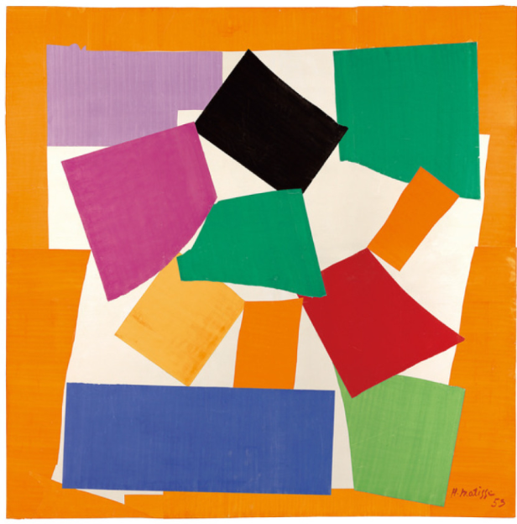  Creating with materials  Collage – just sticking  Leaf printing  Noah’s ark collage pictures  Being Imaginative and Expressive  Farm animal small world | Creating with materials  Firework printing  Christmas Card  Christmas Decoration  Being Imaginative and Expressive  Rangoli chalk patterns outside  Christmas concert | Creating with materials  Make The Three Little Pigs houses  Make story puppets  Being Imaginative and Expressive  Using our imagination to act out traditional tales using masks and props | Creating with materials  Easter Art  Mother’s Day card  Being Imaginative and Expressive  Story sacks to retell Julia Donaldson stories | Creating with materials  Junk modelling – making vehicles  Using blocks to create models and buildings – add emergency service vehicles to block area  Being Imaginative and Expressive  Animal hospital/pets small world | Creating with materials  Beach collages – cutting and sticking  Draw and paint sunflowers and other summer flowers  Make flags and pirate hats  Being Imaginative and Expressive  Pirate role play enhancement outdoors

