

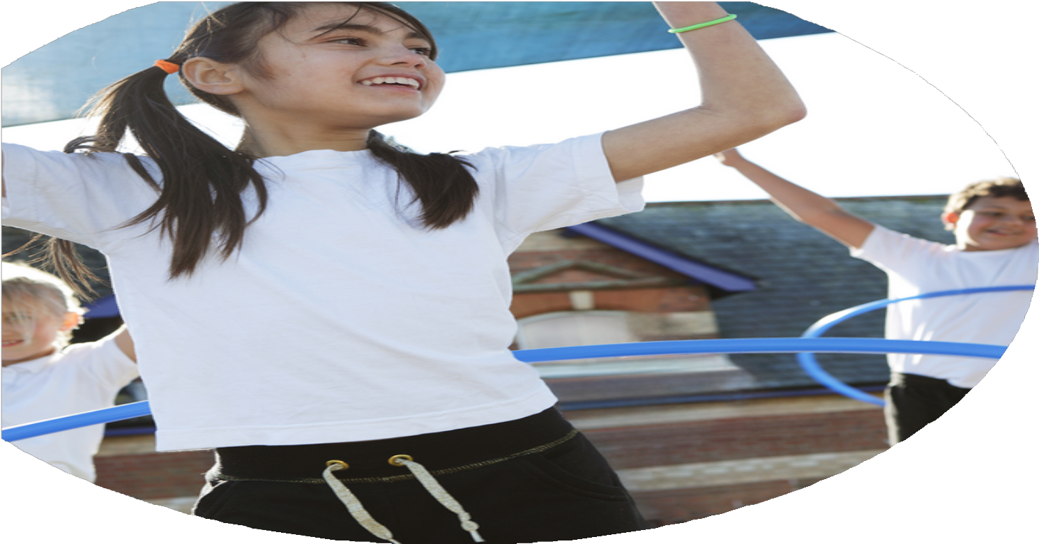
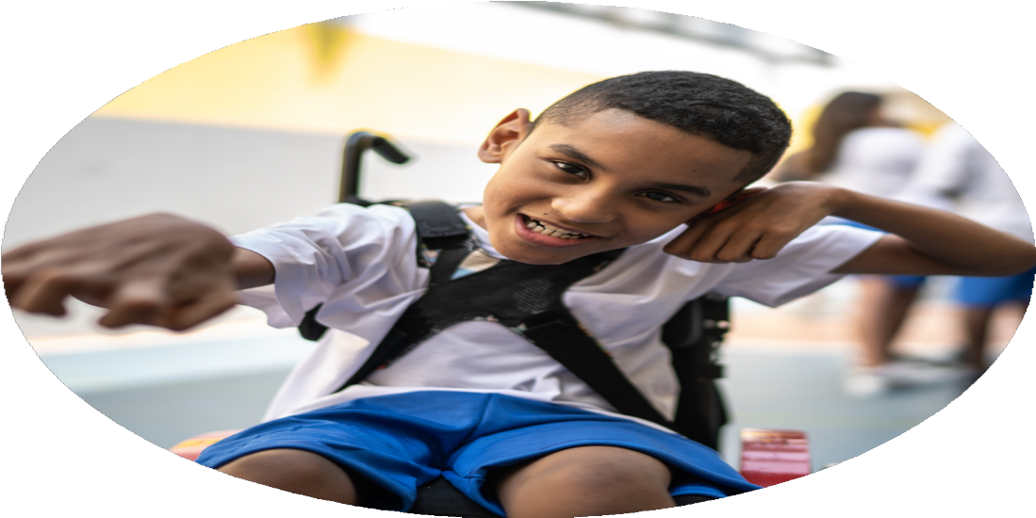




PE Funding

Evaluation Form

Commissioned by

Created by

Images courtesy of Youth Sport Trust

PE Funding Evaluation Form

It is intended that this template should be used as preparation for the completion of the statutory digital reporting tool being introduced this academic year. You can upload data (including swimming) from this template onto this platform once it becomes accessible.
Before you decide how you are going to use the funding for this academic year you should reflect and evaluate the impact of your use of the funding in 2023/24.
All spending of the funding must conform with the terms outlined in the Conditions of Grant document. The template is a working document that you can amend/update during the year.
Based on your evaluation of last year’s funding you should decide what you intend to do this academic year, how you will do it, and what impact you expect it to have.

It is important that the funding is used effectively and based on your school’s needs.
You must use the funding to make additional and sustainable improvements to the PE and sport in your school. You must develop and add to the PESSPA activities that your school already offers.

Summative digital reporting from June 2025 will continue to include swimming and water safety information therefore funding can be used to provide top-up lessons where necessary to ensure pupils meet national curriculum swimming requirements.

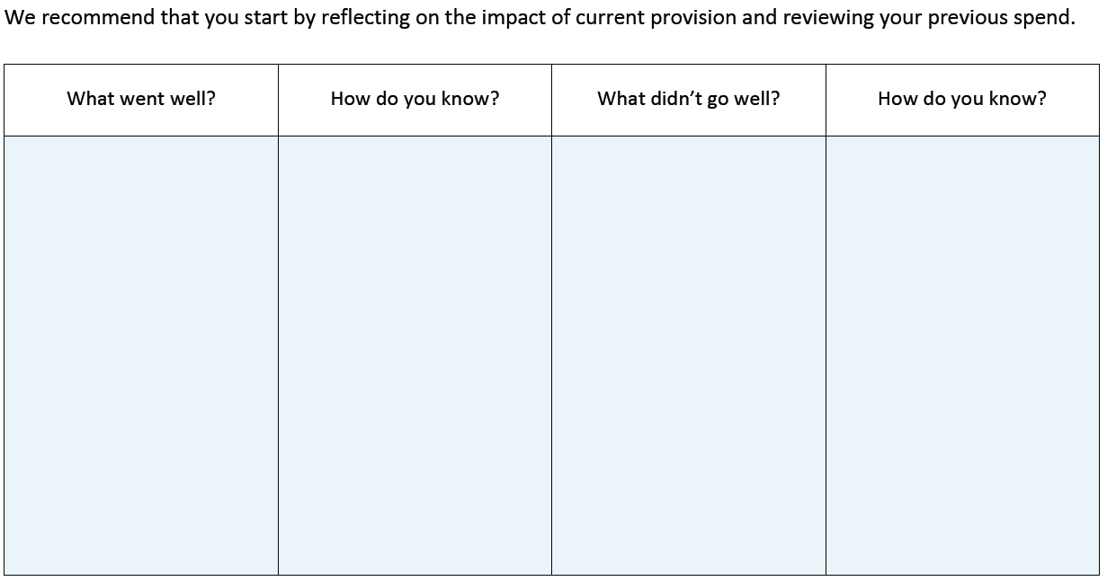
Although we have introduced lunchtime sports sessions/activities, this is not yet embedded. The playground zones also need to be revisited and sustained.

Introducing lunchtime sport sessions/activities for pupils. Training Playground Leaders (Y5) to lead the sessions under the guidance of Specialist Sports TA.

Refreshing and further establishing zoned playground areas with different activities for children to participate in.

Our uptake, and the range of events we attended, increased during the last academic year.

Staff questionnaires, learning walks and pupil voice contributed to the judgement that our PE scheme has been effective in the aims that we had when we introduced it.

We were successful in retain the Platinum School Games Mark status.
Our participation in a range of sporting competitions and events throughout the academic year.

Following the introduction of the Get Set 4 PE scheme,
the skills and confidence of all teaching staff were increased, allowing them to deliver an effective PE curriculum.

Our application to retain the Platinum School Games Mark.

What are your plans for 2024/25?

Intent
How are you going to action and achieve these plans?

Implementation
Continue to implement, embed and sustain lunchtime sport sessions/activities for pupils. Train Playground Leaders (Y5) to lead the sessions under the guidance of Specialist Sports TA.

Refresh and further establish zoned playground areas with different activities for children to participate in.

Attend a range of sporting competitions and events throughout the academic year

Increase skills and confidence of all teaching staff to deliver an effective PE curriculum

Use social media as a means to share and celebrate our sporting news and achievements.

For children to engage in physical activity throughout lunchtime. To give our Upper KS2 children the opportunity to lead sessions to develop leadership skills, confidence and physical activity.

For children to be physically active, purposeful and to raise the profile of physical activity throughout the school day.

For all children within KS2 to be able to take part in a sporting competition or event.

For our Sports TA to upskill staff in the delivery of the teaching of sports and physical activity.

For sporting events to be celebrated, raising the profile of PE and school Games.

What impact/intended impact/sustainability are you
expecting?
How will you know? What evidence do you have or
expect to have?
Learning walks, staff questionnaires, pupil voice

Learning walks, staff questionnaires, pupil voice

Competition results, pupil voice, school clubs

Staff questionnaires, learning walks, pupil voice, PE assessment data

Parent questionnaires, pupil voice, School Games
We expect the impact to be reflected in children’s behaviour and the types of play they engage in at lunchtimes. We also expect children in upper KS2 to develop in confidence and leadership skills that they can take on into their future education.

We expect the levels of physical activity to increase with children having more opportunities to engage in this type of play at lunchtimes.

The children in KS2 will increase in confidence and have new opportunities following sporting competitions and events. They will hopefully find a love of a particular activity or sport that they can take on into their futures.

All of our staff will be confident and competent in delivering effective and inspiring PE lessons in all year groups.

The profile of sports and PESSPA will be highly regarded at Cronton C of E.

What impact/sustainability have you seen?
What evidence do you have?
- TA support in PE lessons led to increased staff confidence and subject knowledge. Staff surveys.
- Structured lunchtime activities and expanded after-school club provision. Learning Walks.
- TA accompanied pupils to competitions, including SEND and girls’ football events.
- Introduction of sensory circuits used regularly throughout the day.
- Increased access to inter-school competitions and inclusive events through partnership membership. Pupil Voice.

- Use of a structured curriculum, integrated assessment tools, and built-in CPD resources. Staff Surveys.

- Survey data collected and used to inform decisions and improvements in PE and sport offer.

Improved quality of PE lessons through staff upskilling and modelling of high-quality practice.
Increased pupil engagement in physical activity during and beyond the school day.
Enhanced inclusion and participation for SEND pupils and girls.
Developed pupil leadership through playground leader programmes.
Improved physical and emotional wellbeing for SEND pupils.
Broadened competitive and festival opportunities for all pupils.
Promoted inclusivity by targeting a variety of learner groups.
Strengthened community links and school identity.
Improved consistency and quality of PE teaching.
Supported staff CPD and curriculum delivery.
More responsive and tailored PE and sport provision based on pupil needs.
Increased pupil satisfaction and engagement.
Fostered school spirit, teamwork, and enjoyment of physical activity.
Reinforced core values such as resilience and healthy competition.

