Littering
The children have continued to help towards the fight of littering by completing another litter pick. We found a whole bin bag of rubbish hiding among the foliage and playground. Remember litter is dangerous for wildlife and can be harmful. Next time you have rubbish in your hand remember to find a bin to place it in.
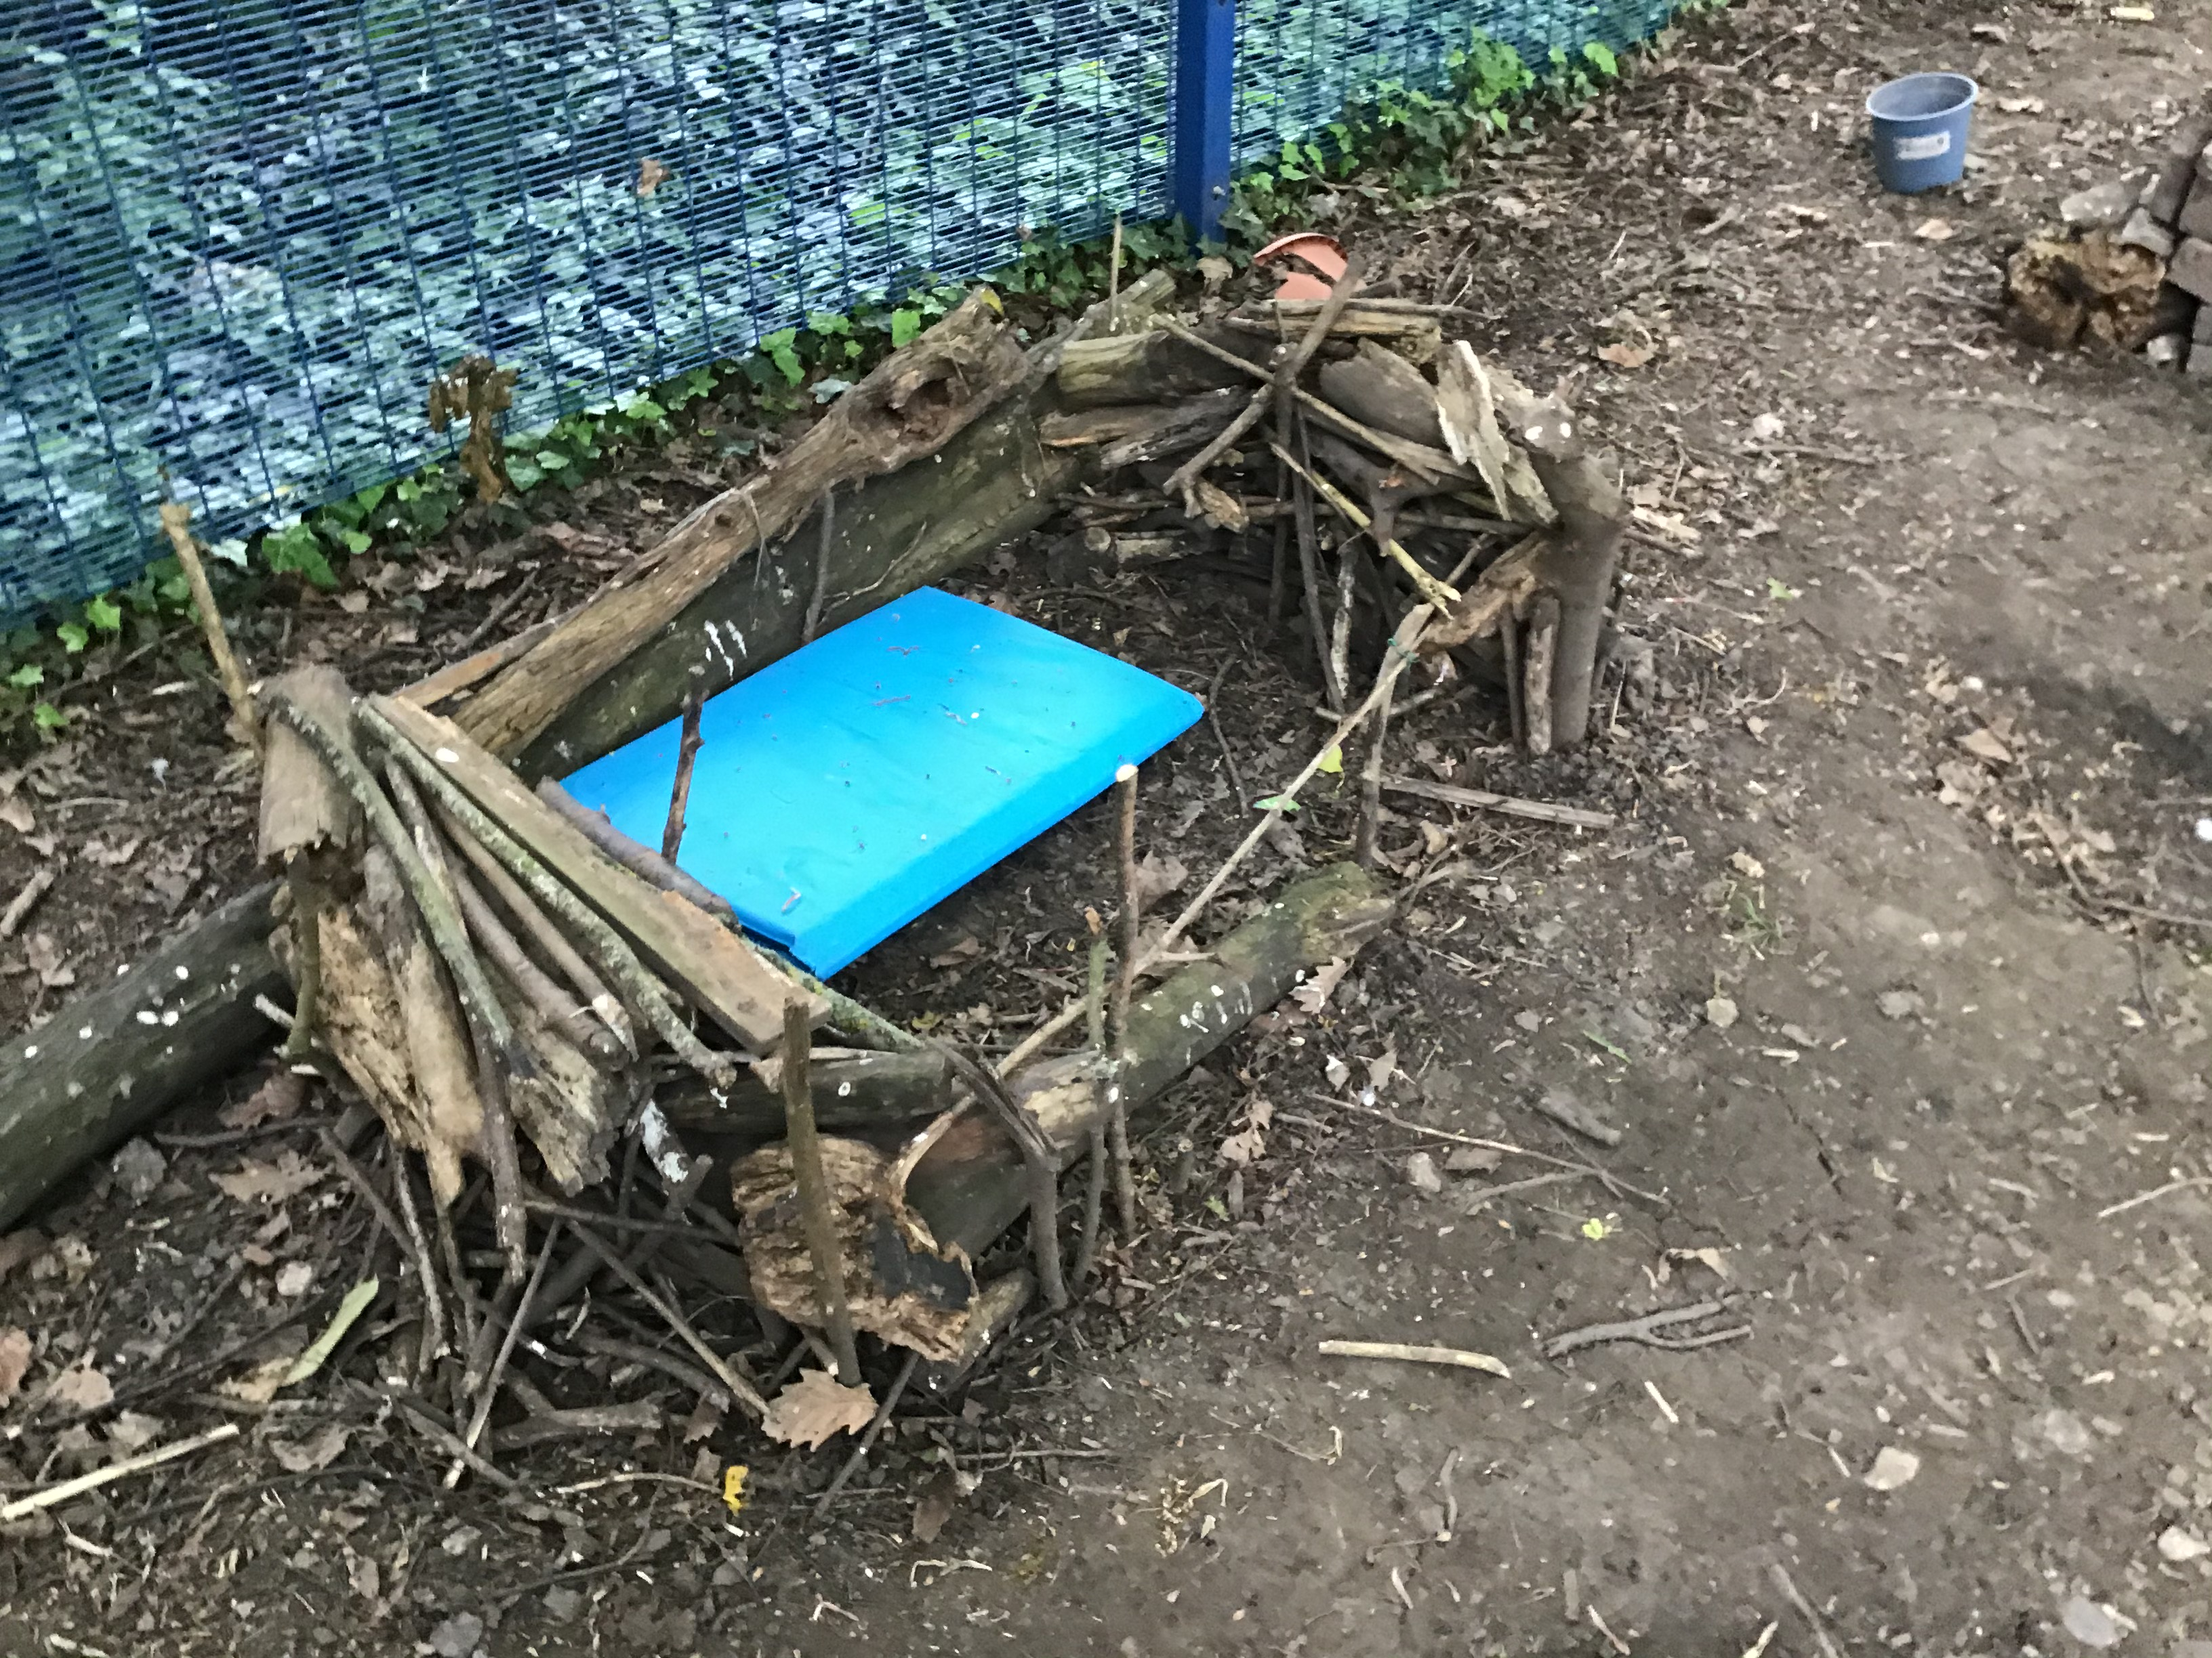
Mini- beast Hotel
The Eco club have created a mini beast area to help the environment and encourage a wide diversity of wildlife.
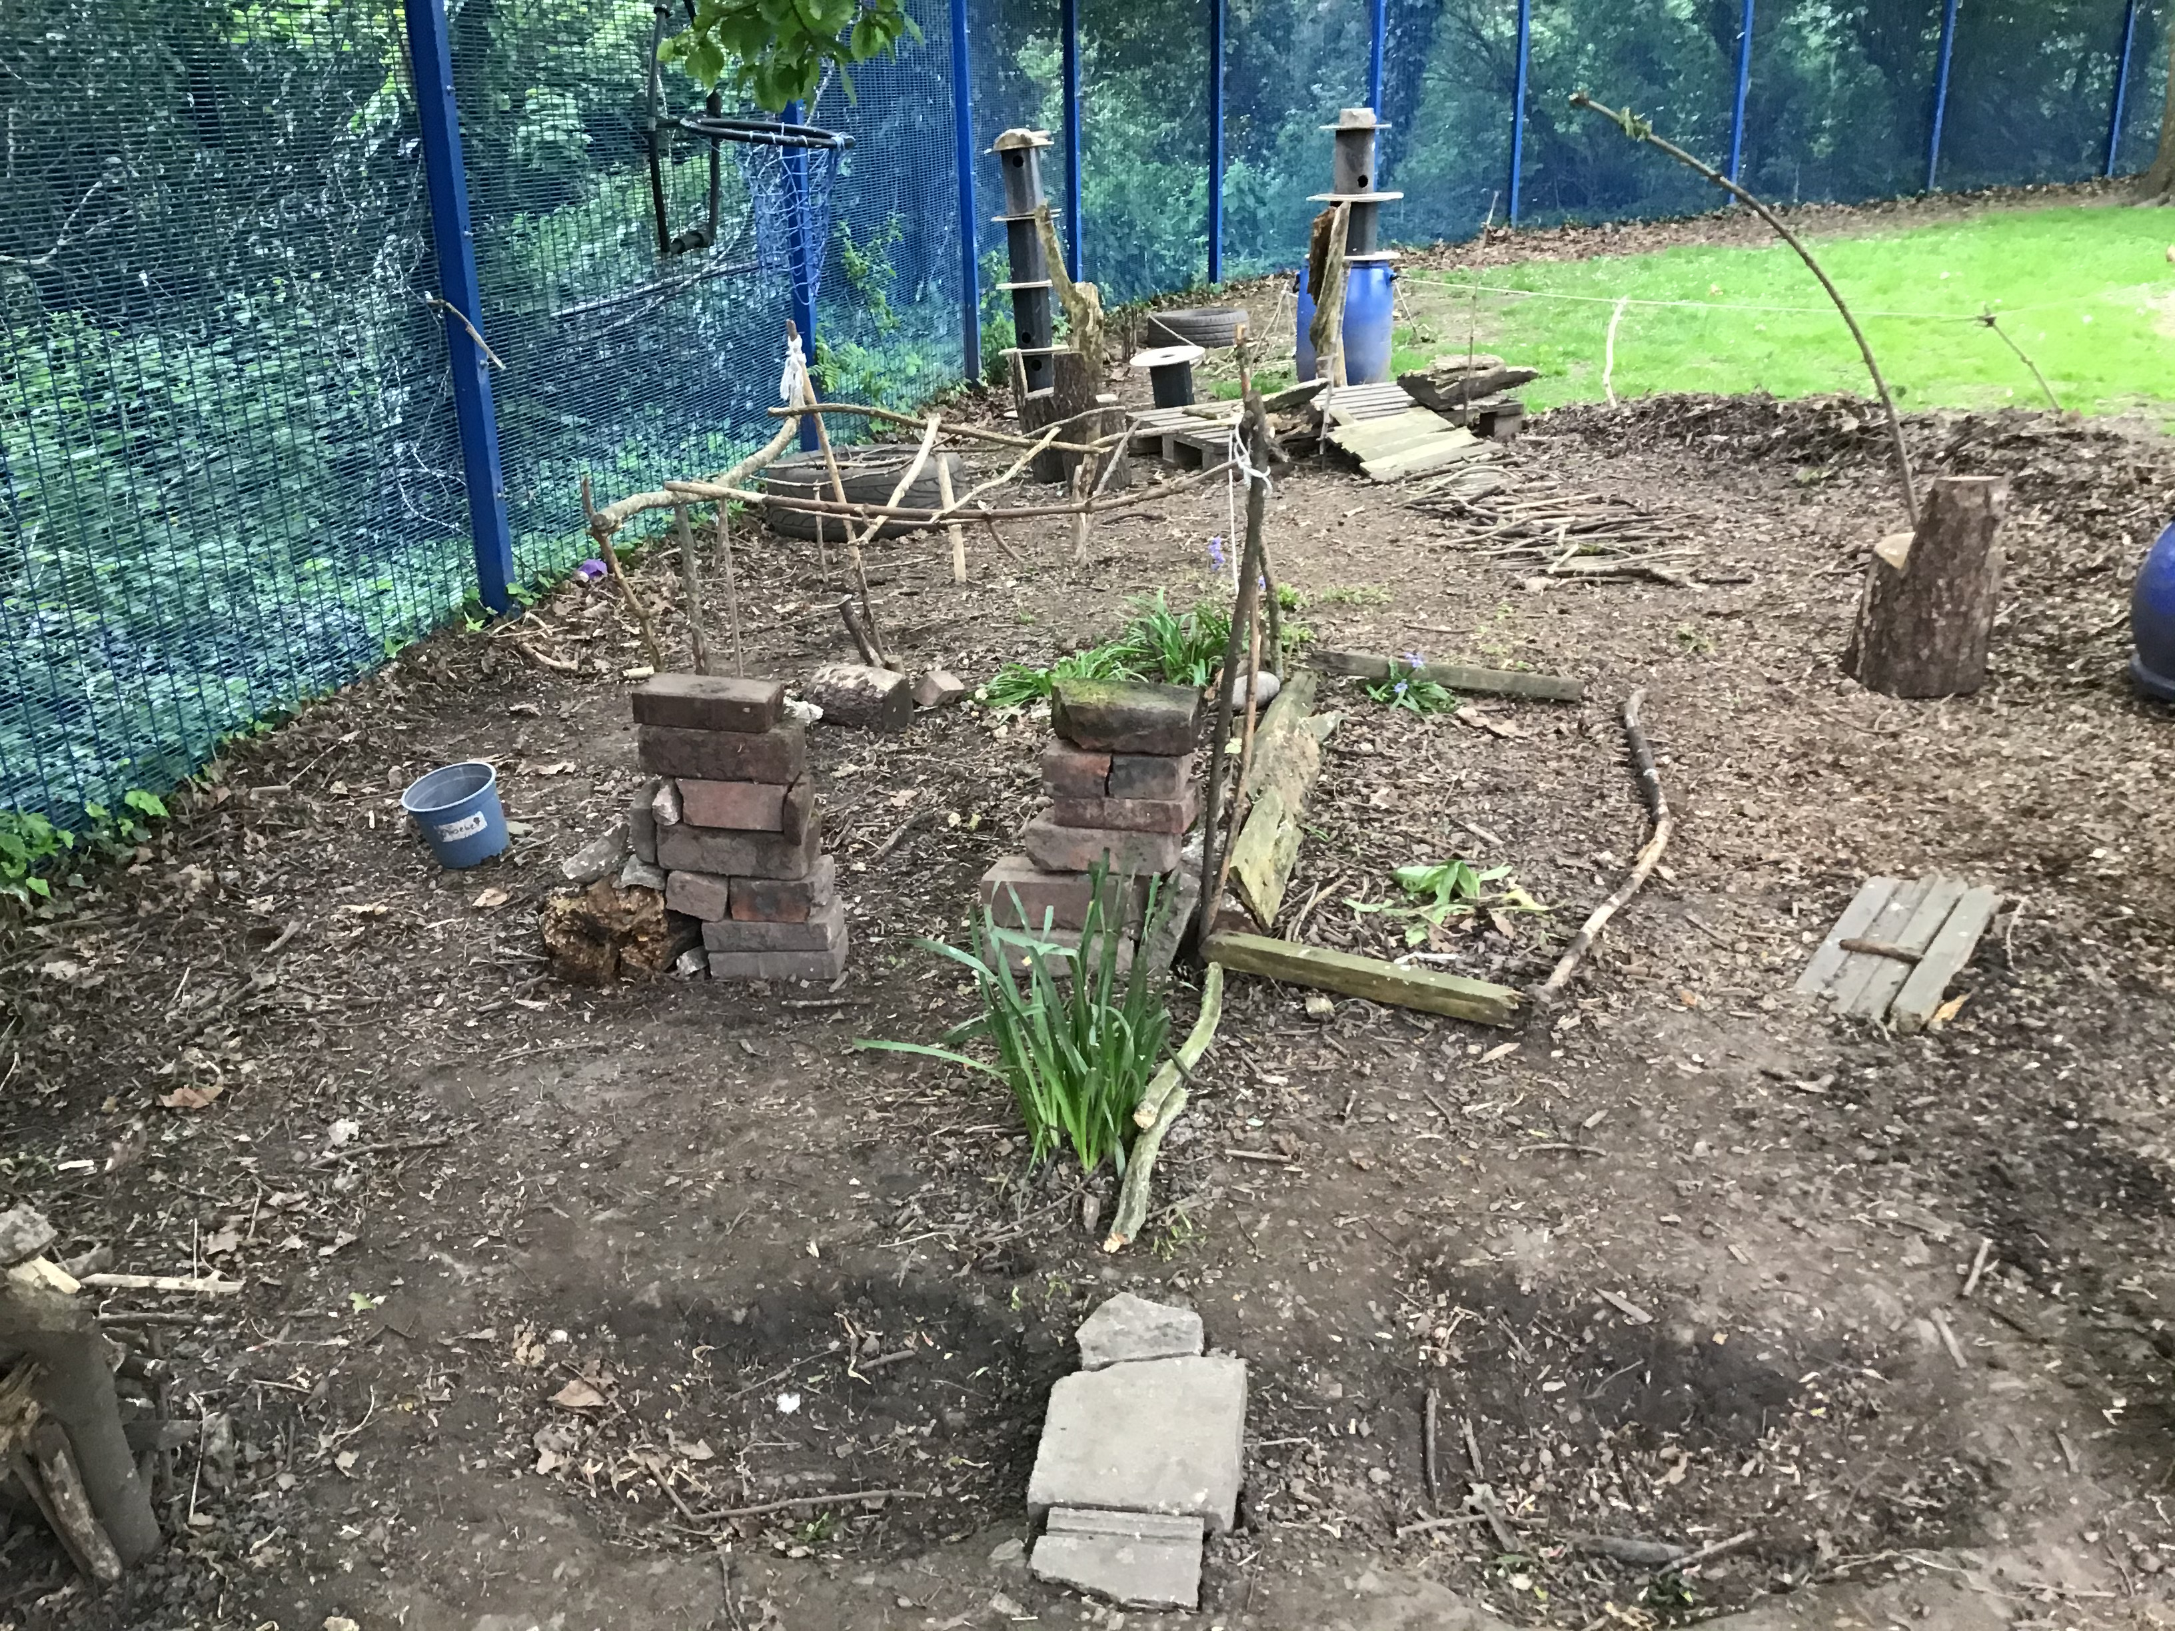
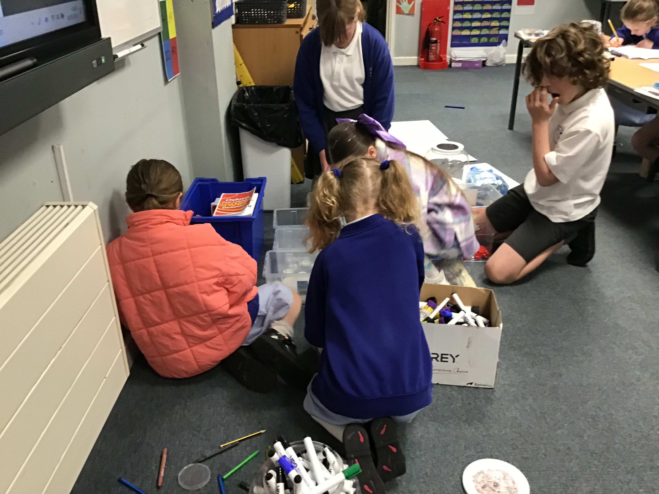
The children have sorted what we have and began to create some art work they would like to create. We are looking at incorporating the air, land and sea aspects to the art to SAVE OUR WORLD.
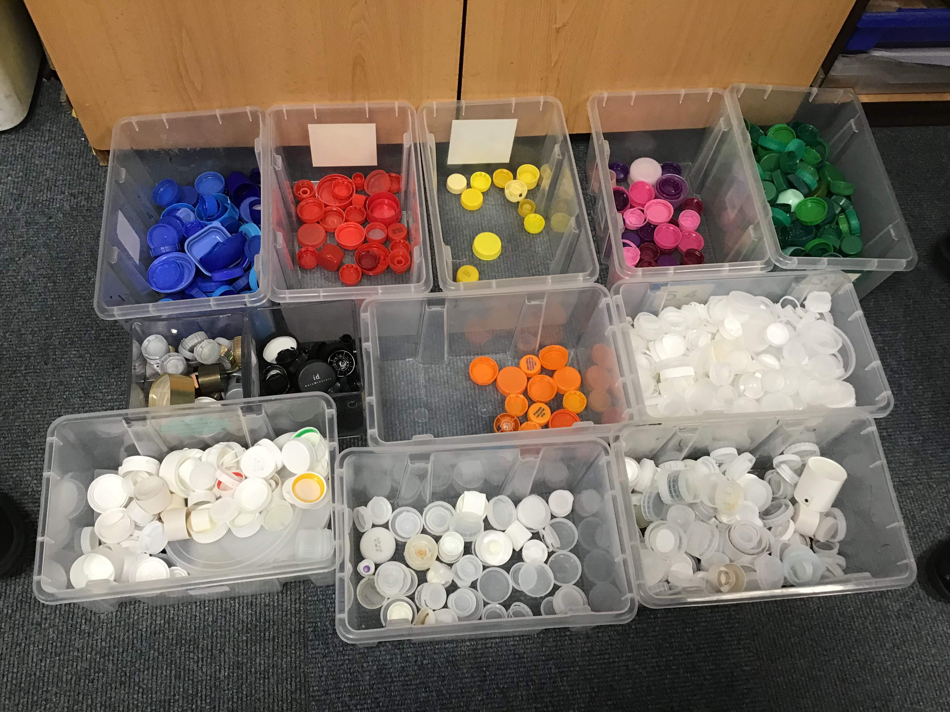
Bottle tops
The children have sorted out the bottle tops donated so far. Thank you for all your help. We will continue to collect lids. If possible, could you send in the colourful lids as we want to make a display using the variety of colours available. We will be creating an art display once we have enough lids.

Eco Newsletter

