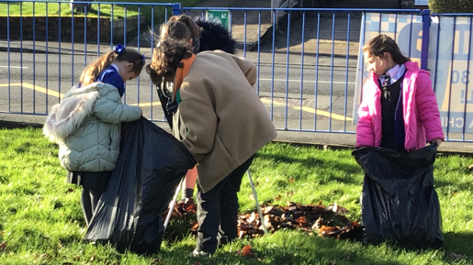
We also completed some litter picking in our school grounds. We found lots of rubbish hidden amongst the leaves and have safely placed it in the rubbish bag with our litter pickers. We hope to do this more often to help the environment.
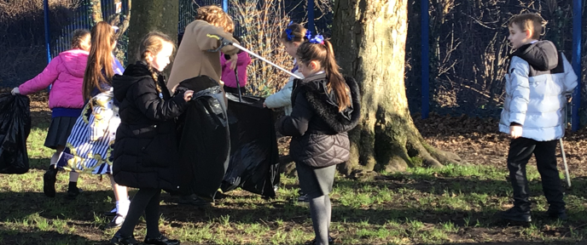
I joined the Eco club so I could help the environment.
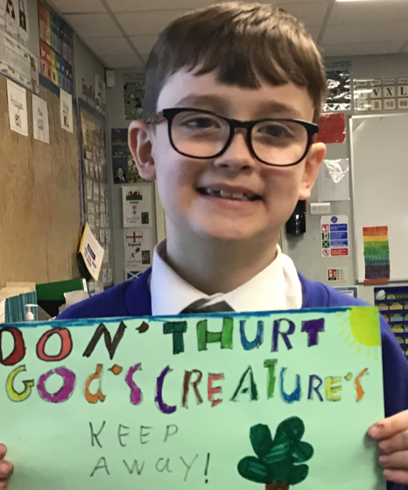
I wanted to join the eco club to help make our planet clean.
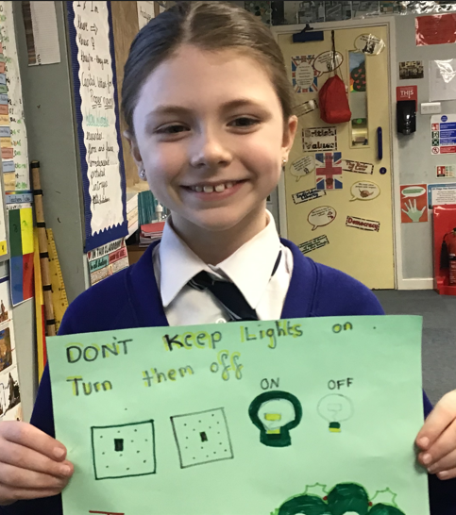
I Joined the Eco club so I could help the environment by not wasting water and helping people to remember to turn the lights off to save electricity.


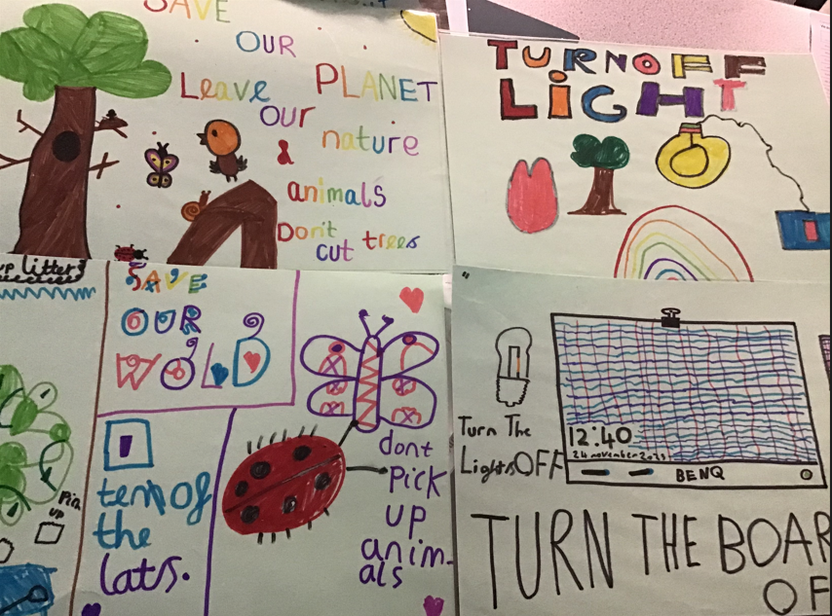
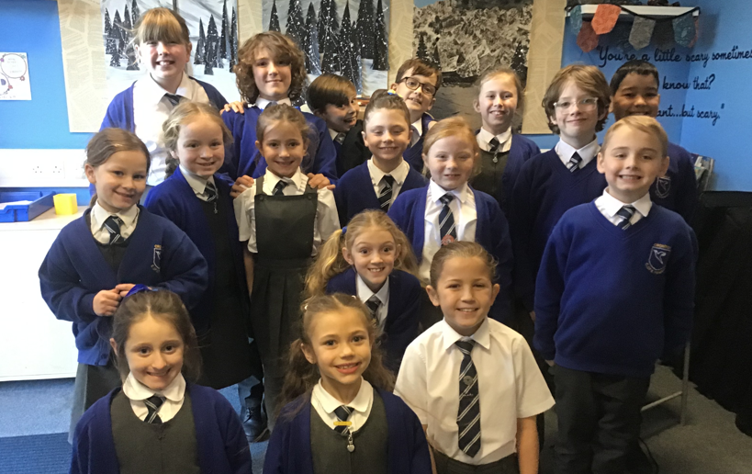
Welcome to the new ECO Avengers fro 2023 -24. We have lots of ideas to help our environment. We hope you will join us on our journey. We have created some posters to remind everyone how they can help. We have focused on:
- Turning lights off to save the electricity
- Picking up litter in our environment
- Not wasting water by turning taps off and not leave them running.
- Protecting all God’s creatures in the environment
- Keep plants safe

Eco Newsletter

