
He has just turned 14.
He loves all sports but his absolute favourite thing to do is cycle.
When he grows up he would like to be a Veterinarian because he loves caring for animals and has two family dogs and his own hamster.

TRY AT HOME
Module 1 –
Wants & Needs
“The very start of managing money”

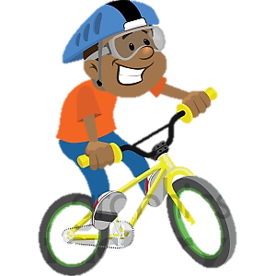
This is George

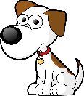
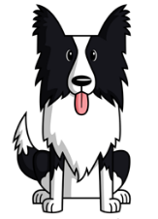


His parents feel he is now responsible enough to have a debit card. This month his parents put £80 on his debit card. Here are all the things he wants to buy this month. Pretend to be George and decide what you will spend your £80 on. Remember to prioritise your NEEDS before WANTS.
Item | Price
New Xbox game - (George could buy a pre-owned game for £14.99) | £29.99
New iPhone Case | £5.00
Deodorant | £1.50
Phone Contract | £20.00
Sweets | £3.50
Revision Books - (George will need good grades to become a Vet) | £8.00
New inner tube for his bike - (George cycles to school but he has had a puncture for almost 2 weeks now and has had to catch the bus) | £5.00
Hamster Food | £7.50
Scientific Maths calculator | £8.00
School Dinners Month (George could bring a packed lunch as a cheaper alternative which his parents would pay for) | £20.00
Re-usable water bottle (George buys a lot of bottles of water) | £7.00
School museum trip | £5.00
Cinema ticket | £6.50
Anniversary Present for his Mum and Dad | £10.00
Helmet (George lost his previous one) | £15.00

Consider what items George NEEDS and the items he WANTS. Write down your chosen items in the shopping list.
George’s shopping List

NEEDS WANTS

Total: £ _________

Total savings (if any) : £ ______________

Can you now explain why you have chosen these items?
_______________________________________________________________________________________________________________________________________________________________________________________________________________________________________________________________________________________________________________________________________________________________________________________________________________________________________________________________________

Task 2 - Money Saving Tips

1. | Turn lights and appliances off when not in use | 2. | Check out deals at local sports centres and local gyms
3. | Have showers rather than baths | 4. | Use public transport more frequently
5. | Buy energy saving light bulbs and appliances | 6. | Walk or cycle short journeys
7. | Fill the kettle with the amount of water that you require | 8. | Enquire about child and young person’s discounts
9. | Buy supermarket products instead of branded foods | 10. | Only put the central heating on when it is cold
11. | Evening and weekend calls are often cheaper than weekdays calls | 12. | Shop around for the best phone deals there may be cheaper options
13. | Find out if pay as you go is cheaper than contracts | 14. | Avoid eating out, using ready meals and takeaways too often
15. | Shop during the sales and stick to the sale stuff | 16. | Take a packed lunch rather than buying lunch every day
17. | Make sure the TV is switched off when no-one is watching | 18. | Only put the washing machine on when there is a full load of clothes to wash
19. | Some cinemas offer cheaper tickets at different times on the week | 20. | Buy supermarkets own brands rather than expensive brands and look for bargains


Which ones do you use in your house? Tick these and put a cross
next to the ones you are not able to use.

List the FIVE tips that are most important to your family at the moment
1. ______________________________________________________________________-_
2.________________________________________________________________________
3.________________________________________________________________________
4.________________________________________________________________________
5.________________________________________________________________________

Can you list any other money savings tips that are not on the list
You can share them with each other in class as part of the DebtAware ‘Top Tips’ Challenge
____________________________________________________________________________________________________________________________________________________________
________________________________________________________________________________________________________________________________________________________________________________________________________________________________________________________________________________________________________________________

